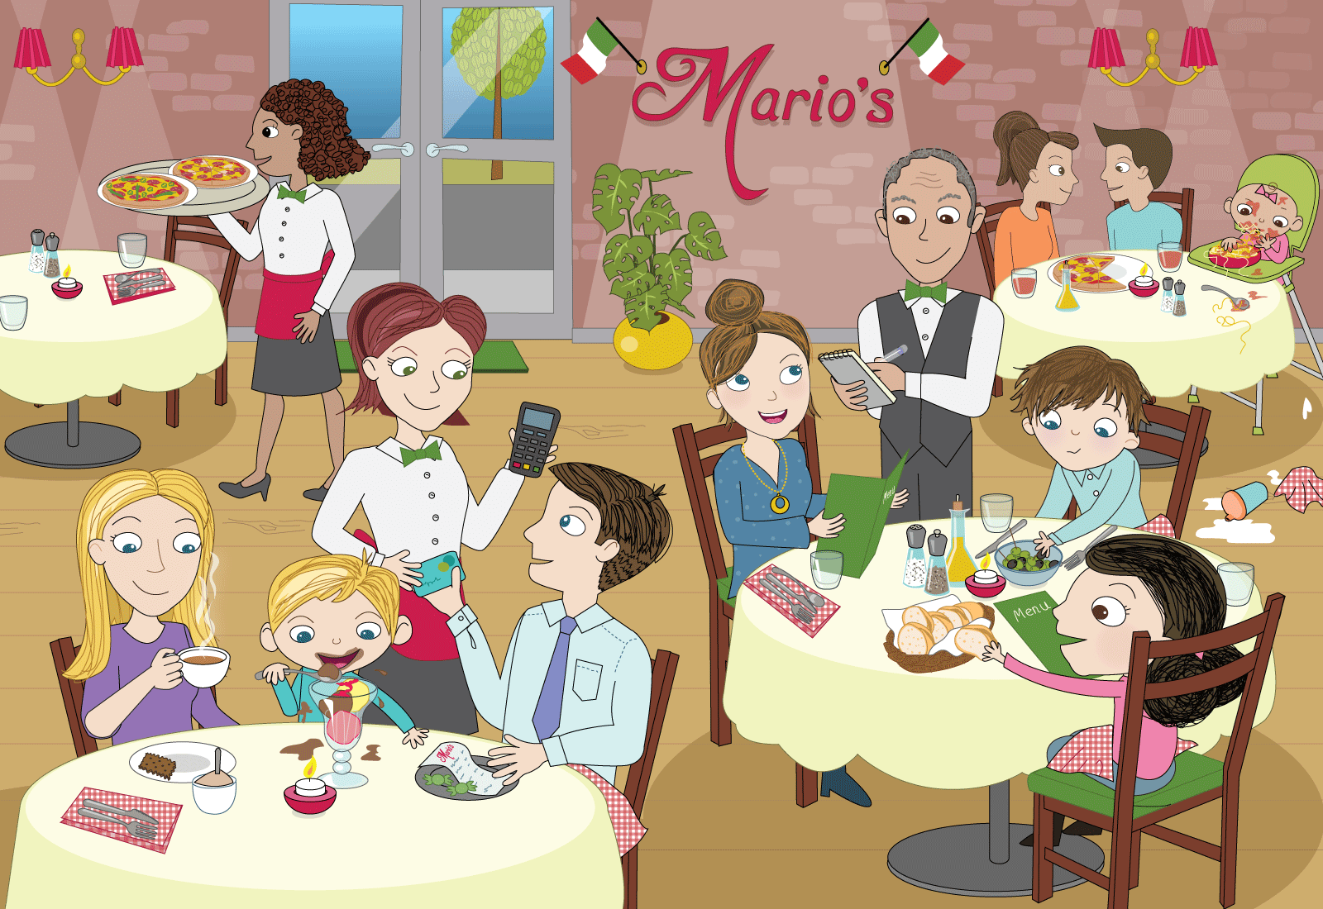
Class | Senior Infants | Theme | Food
Unit | 14 | Subtheme | Eating out
Unit Genre | Recount
Vocabulary | Tier 1 examples: restaurant, waiter/waitress, menu, pizza, pasta,  spaghetti, table, tablecloth, food, water, glass, jug, knife, fork,  plate, bread, salt, pepper, notepad, napkin, bill, money, dessert  Tier 2 examples: Italian flag, olive oil, cutlery, candle, serve, spill, carry  apron, customer, flavour, choices  Tier 3 examples: greet, condiments, appetisers, cutlery, ravenous, choices
Lesson resources | Ice-cream sundaes image, Multimedia Links
Element | Learning Outcome | The child should be able to …
Communicating | LO 1 | Participate in and enjoy rhymes and tongue twisters
 | LO 2 | Understand the social conventions of language, e.g. using language to greet
 | LO 3 | Work collaboratively using language to negotiate  Give and take turns
Understanding | LO 4 | Demonstrate metalinguistic awareness, e.g. re-ordering syntax  Understand morphological growth, e.g. like/dislike  Use complex sentences and past, present and future tense
 | LO 5, 6 | Practise articulating sound clusters  Use a wide range of nouns and adjectives to explore the poster scene, including synonyms and idiomatic language
 | LO 7 | Demonstrate understanding of category memberships
Exploring and Using | LO 10 | Categorical terms, e.g. cutlery, appetisers, special occasions
 | LO 11 | Give a recount and retell someone else’s recount
 | LO 13, 14 | Use language to present information using topic-specific language, e.g. food rituals in other cultures  Use language to describe food, e.g. creating and naming a sundae

Fortnightly plan
Lesson 1 | Digital poster (Story mode)  Digital poster (Explore mode) – Talk and Discussion  Dialogue Dilemma!  Rhymes and Tongue Twisters | Lesson 3 | Digital poster (Explore mode) – Talk and Discussion  Digital poster (Activity mode) – Spot the Difference  Pair Talking Task: Strawberry Supreme  Design and Draw: Ice-Cream Sundae
Lesson 2 | Digital poster (Story mode) – Recap  Digital poster (Question mode)  Eating Food  Turn and Tell: Food on Special Occasions  Odd-One-Out | Lesson 4 | Digital poster (Label mode)  Digital poster (Poem mode) – ‘The Meal’

Lesson 1
Digital poster (story mode) LO 1
Play either the Story mode 1 (starters) or Story mode 2 (flyers) for the class, depending on the ability level.

Digital poster (explore mode): Talk and discussion LO 4, 5, 6, 7, 10, 14
Go to the Explore mode of the poster. Zoom in on the word ‘Mario’s’. Ask children the following questions:
- Where do you think the family is? (In a restaurant)
- What is the restaurant called? (Mario’s)
- What kind of restaurant is Mario’s? (Italian)
- How do you know? (Name/flag)

Zoom out and focus on the whole poster. Ask children the following questions:
- Are there any other clues that tell us this is an Italian restaurant? (Food – pizza, garlic bread, olives, olive oil)
- Do you have a favourite restaurant? What is it called? What type of food can you get there? Why is it your favourite restaurant? (The food is delicious/yummy/tasty/scrumptious/mouth-watering)
- What other types of places can we go to eat out? (hotel, café, coffee shop)

Focus on Kate’s family at the table. Scaffold the children to use some of the following vocabulary: table cloth, candle, serviettes/napkins (where do we put the napkins/why?) cutlery (knife, fork, desert spoon), glasses, salt/pepper/olive oil (condiments), bowl of olives, basket of bread, appetisers, menu, etc.
Ask children the following questions:
- What is happening here? (e.g. Mum is ordering food from the menu, the waiter is writing down the order, Kate and Jack are helping themselves to appetisers because they are hungry/starving/ravenous/peckish etc.)
- Spotlight the menu. The menu tells us the choices of food available to order in the restaurant (starter, main course, dessert, drinks). What food choices do you think are on the menu in this restaurant? What food do you like to choose/order when you go to a restaurant?
- How is going to a restaurant different from eating at home? e.g. going to a restaurant is different from eating at home because you dress up/there lots of people/greater choice of food from the menu/we don’t have to cook or clean-up/we pay at the end, etc.)
- Who works in a restaurant? (waiter/waitress, chef/cook, receptionist/host/hostess)
- What do we call the people who come to eat in a restaurant? (Customers)
- Sometimes we take the food away and eat it at home. What do we call this food? (Fast Food, takeaway). Why? What is your favourite Fast Food? Describe it and make our mouths water!
- Spotlight the waiter/waitress. What do we call this person who works in a restaurant? How do you know? (Uniform, notepad and pen, tray of food); Do you notice anything different about what they are wearing? (apron). Why do you think they are wearing an apron? Do you ever wear an apron?
- What does the waiter/waitress do in the restaurant? (greet the customer, take the food order, bring food/drink to the table, take payment, give change)

Teacher-in-Role: Are you ready to order?
Take on the role of waitress and have groups of four children take on the role of customers. Role play a restaurant scenario with the children as follows:
Teacher: (Greeting) Hello/good evening/welcome/how are you today?
Children: Hello/good evening/thank you/how are you? We would like a table for four please.
Teacher: Of course, follow me please. Have a seat. Here are your menus.
Children: Thank you.
Teacher: May I take your order?
Children: I would like …
Teacher: Of course. Can I bring you something to drink?
Children: Yes, I would like …
Teacher: Here is your food. Enjoy!

Repeat the role play a number of times. Give children an opportunity to role-play independently.

Dialogue Dilemma! LO 4, 12
Put the following dilemma to the children:
Oops! The waiter/waitress and the customer are confused. Their words are coming out in the wrong order!
Can you sort them out?
Read out the mixed-up dialogue before and have children say them in the correct order.
Waiter/Waitress: evening good welcome
Customers: you thank
W: today are you how
C: you thank well very
C: four for table
W: me please follow
W: seat a have
W: here menus your are
C: would like I please pizza
W: can I you bring drink a

Rhymes and Tongue Twisters LO 1, 5, 6, 12
Encourage children to recite these rhymes and tongue twisters in pairs or small groups.

Sippity Sup
Sippity sup, sippity sup,
Bread and milk from a china cup.
Bread and milk from a bright silver spoon
made of a piece of the bright silver moon.
Sippity sup, sippity sup,
Sippity, sippity sup.

Annie the ant ate an apple
How many cookies could a good cook cook if a good cook could cook cookies?
Fresh fried fish, fish fried fresh
My Mummy makes me yummy muffins on Mondays

Lesson 2
Digital poster (story mode): Recap
Play either the Story mode 1 (starters) or Story mode 2 (flyers) for the children again. Make sure they understand all of the vocabulary.

Digital poster (question mode) LO 8, 9, 13, 14
Go to the Question mode of the poster. Listen to each question and discuss the answers with the children briefly.

Q1. | What kind of restaurant are Mum, Kate and Jack eating in?
Q2. | What is Jack eating?
Q3. | What special occasion are Kate's family celebrating?
Q4. | What is the boy at the next table eating?
Q5. | What do you think Mum is saying to the waiter?
Q6. | Do you think the baby is enjoying her dinner? Why?
Q7. | Would you like to work as a waiter? Why?
Q8. | Why do you think people like to go to restaurants on special occasions?
Q9. | How do you like to celebrate your birthday?
Q10. | If you were to open up your own restaurant, what type of food would be on your menu?

Eating Food LO 4, 5, 6, 7, 13
Play Apples and Bananas from Barney for the class:
https://www.youtube.com/watch?v=Cm8japh-EwY

Use the song as a starting point to discuss the tenses of the verb ‘eat’ and synonyms for it.
Ask the class, what do we do with food? We eat food!
Every day at lunch time we eat our lunch. What did we do at lunch time yesterday? (We ate our lunch)
Teacher makes a chewing action with mouth. What am I doing now? (eating food)
If we are really hungry we say we gobble food (eat something quickly and noisily).
Kate and Jack were ravenous, so they were tucking into the food at the restaurant because the food was scrumptious! If we are not very hungry we say we nibble food (take small bites of food).
Sometimes we have to crunch food if the food is hard (crush food with our teeth).
Can you think of a food that you would need to crunch? (carrot, celery, toast, nuts, crisp, biscuits)

Food mime
Organise children in pairs. One child mimes eating food in a particular way (e.g. gobbling, nibbling, crunching, tucking in, etc.) The other child then describes what their partner is doing, e.g. I think you are gobbling your food because you are ravenous/Nibbling because you only want a small bit of food/Crunching because the food is hard to crush/Tucking into food because you are very hungry and the food is scrumptious

Knee to Knee and Eye to Eye
Organise children in pairs and encourage them to discuss the foods they like and do not like to eat.
Partner A: I like … because it is …
Partner B: I like … because it is …
Partner A: I dislike … because it is …
Partner B: I dislike … because it is …
e.g. horrible, disgusting, nasty, smelly, revolting, etc.

Turn and Tell: Food on Special Occasions LO 5, 6, 7, 13
Ask children, why did Kate and Jack and Mum go to the restaurant? (to celebrate Mum’s birthday)
Remind the children of the food we eat for a birthday party (you could revise the vocabulary from Unit 2 here)
Elicit the names of other special occasions we celebrate with special foods, e.g. Halloween, Christmas, Easter, Christening, Wedding) and encourage children from other cultures to share their celebratory food and eating rituals with the class, or with their partner (e.g. Thanksgiving, Chinese New Year, Ramadan, Hanukkah)

Odd-one-out LO 5, 6, 7
Ask children to identify which food in each list does not belong, encouraging them to explain why:

Sweets, crisps, breakfast cereal, cake (Birthday party foods)
Sushi, pizza, garlic bread, spaghetti (Italian food)
Christmas cake, smarties, turkey, mashed potatoes (Christmas dinner)
Nuts, pumpkin, barmbrack, toast (Halloween)
Hamburger, chicken casserole, fries, fizzy drink (Fast food)

Lesson 3
Digital poster: Talk and discussion LO 4, 5, 6, 7, 11
Go to the Explore mode with the children again. Zoom in on the second family in the restaurant. Ask the children the following questions:
- Is this family ready to order their meal? (No, they are at the end of the meal)
- How do we know they are at the end of the meal? (Mum is drinking steaming coffee/tea, the small boy is eating/slurping ice-cream for desert, Dad is paying the bill with a credit card)
- Scaffold the children to relay the sequence of events in a restaurant – first we are greeted at the door by the host/hostess, next the waiter shows us to our table, then we look at the menu and when the waiter comes to the table he/she takes our order and writes it down on a notepad. After a while the waiter brings our delicious food which we eat/enjoy/tuck into. When we have finished eating, the waiter brings the bill and then we pay for our meal.

Vocabulary to cover during discussion:
Nouns Use the spotlight tool to focus on different items as they are named. Use the pen tool to categorise the various items after they have been named, e.g. circle… (menu, tableware, waiter/waitress)
Verbs, e.g. (greet, give/take order, bring, serve, pay …)
Adjectives, e.g. (icy, cool, cold, chillled, freezing, delicious, tasty, scrumptious, creamy)
Categorical terms, e.g. appetisers, condiments, cutlery, special occasions
Synonyms, e.g. delicious/yummy/tasty/scrumptious/mouth-watering; hungry/starving/ravenous/peckish; eat/gobble/nibble/tuck into

Restaurant Recount
Scaffold the children to give a recount of a time when they were at a restaurant, including who went, when, why, where, what happened in the restaurant, what they ate, how it tasted, etc.
Having modelled this with the whole class, encourage children to give recounts in pairs, and to share their partner’s recount with the rest of the class.

Spotlight the small boy eating ice-cream. Ask children the following questions:
- What flavours of ice-cream is he eating? (chocolate, vanilla, strawberry)
- Do you like to eat ice-cream? Why? (icy, cool, cold, chillled, freezing, delicious, tasty, scrumptious, creamy)
- What types of ice-cream do you like best? (whipped, wafer, cone, cornet, tub, twister, banana split) What ice-cream flavours do you like? (chocolate, vanilla, raspberry ripple, chocolate chip, cookie dough); What toppings? (strawberry, butterscotch, chocolate sauce, flake, sprinkles, smarties, buttons)

Digital poster (activity mode): Spot the difference LO 2, 13
Go to the Activity mode of the poster and display the two images. Ask the children to work in pairs to identify differences. Encourage the children to identify and explain the differences to the class.

Remember: It is important to encourage the children to use language rather than pointing, e.g. ‘The waiter is wearing a bow-tie in the picture and not in the other OR in the picture on the left/on the right.’

Pair Talking Task: Strawberry Supreme LO 4, 5, 6, 7, 14
Display the image included in Lesson Resource 1 showing different types of ice-cream sundae.

Organise children in pairs ad have them describe which is their favourite and why.
Encourage the children to describe clearly using language only and without pointing, e.g. My favourite ice-cream sundae is the one with chocolate, vanilla and mint ice-cream and chocolate sauce in a glass bowl with two chocolate wafers on top. I like this one because it has wafers and chocolate sauce, which is my favourite.

Design and Draw: Ice-cream Sundae LO 3, 12
In groups, children design their ideal/favourite ice-cream sundae. One child draws the image, incorporating the ideas from other children in the group. Encourage children to give their sundaes imaginative titles, e.g. chilly chocolate treat, super strawberry surprise, etc. Encourage groups to present (tell) their instructions for making their favourite sundae to the class, using sequencing words. Encourage all members of the group to contribute to the presentation.

Lesson 4
Digital poster (label mode) LO 6, 7
Go to the Label mode of the poster. Review the vocabulary. Have the children take turns dragging the labels onto the correct location in the poster.

Digital poster (poem mode): ‘The Meal’ LO 1, 12
Go to the Poem mode of the poster and play the poem ‘The Meal’ by Karla Kuskin.

The Meal
By Karla Kuskin

Timothy Tompkins had turnips and tea.
The turnips were tiny.
He ate at least three.
And then, for dessert,
He had onions and ice.
He liked that so much
That he ordered it twice.
He had two cups of ketchup,
A prune, and a pickle.
“Delicious,” said Timothy.
“Well worth a nickel.”
He folded his napkin
And hastened to add,
“It’s one of the loveliest breakfasts I’ve had.”

Encourage children to speak the poem with appropriate expression, pace and intonation.
Ask children the following questions:
- What’s wrong with the menu? Listen to the poem and identify what is wrong with Timothy’s menu. Encourage/scaffold the children to identify the mistakes in Timothy’s meal, using complete and detailed sentences Try to elicit vocabulary such as horrible, disgusting, nasty, tasteless, unappetising, unpleasant, unsatisfying, disagreeable, etc.
- Scaffold the children to replace some of the bolded words in the poem with words that would make a delicious, tasty meal for Timothy.

Organise children in groups or pairs and give them the following tasks:
- Devise a menu for a proper meal that Timothy could eat
- Draw the new menu. Present your menu to the class and explain why it would be a much better menu than the one that Timothy ate.

Lesson Resource 1

