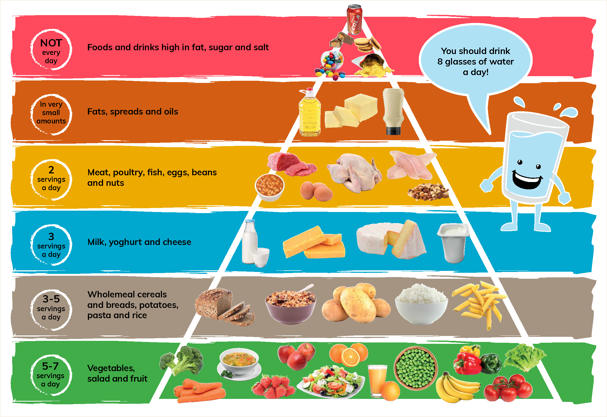
Class | Senior Infants | Theme | Food
Unit | 13 | Subtheme | Healthy foods
Unit genre | Procedure
Vocabulary | Tier 1 examples: vegetables, soup, peas, salad, fruit juice, lettuce,  oranges, strawberries, carrots, broccolli, peppers, tomatoes,  apples, bananas, brown bread, potatoes, pasta, rice, milk, cheese  Tier 2 examples: pyramid, diet, dairy products, sugar, portion, activity, alike, picky  Tier 3 examples: food option, vine, stalk, pips, sprout, alike, ingredients, garnish, layer
Lesson resources | Multimedia links
Element | Learning outcome | The child should be able to …
Communicating | LO 1 | Enjoy participating in verbal games.
 | LO 2 | Speak a poem with appropriate intonation and expression.
Understanding | LO 4 | Use complex sentences and explain opinions and feelings.  Use the continuous present, e.g. is cutting  Use the prefix ‘un’, e.g. healthy/unhealthy.
 | LO 5, 6 | Use a wide range of nouns and adjectives to explore the poster scene including verbs, e.g. slice, spread
 | LO 7 | Understand and use idiomatic language.
Exploring and using | LO 10 | Understand and use categorical terms, e.g. ingredients, utensils, method, wholegrain foods, fillings.
 | LO 11 | Retell parts of favourite fairytales.
 | LO 13 | Use language to describe and give a commentary on something.

Fortnightly plan
Lesson 1 | Digital poster (Story mode)  Digital poster (Explore mode): Talk and discussion  Freeze chant  Make and mime: At the sandwich bar | Lesson 3 | Digital poster (Explore mode): Talk and discussion  Digital poster (Activity mode): Who am I?  Sing together! ‘The Healthy Eating Song’  Food teasers  Digital poster (Activity mode): Multiple-choice questions
Lesson 2 | Digital poster (Story mode): Recap  Digital poster (Question mode)  Storytime: Gregory the Terrible Eater  Favourite food  Fairytale food  Word tennis: Food pairs | Lesson 4 | Digital poster (Label mode)  Digital poster (Poem mode): ‘My Sister’s Eating Porridge’

Lesson 1
Digital poster (Story mode) LO 1
Play either the Story mode 1 (starters) or Story mode 2 (flyers) for the class, depending on the ability level.

Digital poster (Explore mode): Talk and discussion LO 4, 5, 6, 7, 10, 11,13, 14
Go to the Explore mode of the poster. Ask the class, ‘Why do you think this is called a food pyramid?’

Use the conceal tool to hide everything but the bottom row of the pyramid. Ask children the following questions:
- What foods can you name on this row of the food pyramid?
- Which of the foods are fruit/salad/vegetables?
- Can you name the foods that are berries?
- Can you find a food that is green/red/yellow; round/long/smooth; has skin which you peel; grows on a vine; rhymes with parrot/knees; has a stalk; has pips?
- What is your favourite fruit/salad/vegetable? Why? (My favourite … is …because …)

Reveal the next two rows of the pyramid. Ask the children the following questions:
- Can you find something that starts with a ‘p’ sound?
- Can you find something that we slice/serve in a bowl/spread/drink?
- Can you find a soft/hard/fluffy/crisp food?
- Can you find something that rhymes with please/silk/head/mice?
- Can you find dairy foods on the poster?

Play one of these videos of the song ‘One Potato, Two Potato’ for the class:
https://www.youtube.com/watch?v=efMHLkyb7ho (without actions)
https://www.youtube.com/watch?v=dI3kGu7MrSk (with actions)

For the next part of this lesson, you will need a potato for each child in the class (or you will need to ask each child to bring in a potato). Organise the children into pairs and ask them the following questions:
- Look at your potato. Can you find the eye of the potato? This is the bud from which a new potato can sprout. Why do you think it is called the ‘eye’?
- Draw a nose, mouth, ears and hair on your potato and give it a name. Introduce your potato friend (Mr Potato) to your partner, e.g. Good morning, my name is Peter. I am a potato. I came from the ground. You can cook me. I am one of your healthy food options.
- What can you make from a potato? (boiled, mashed, baked, roast, chips, garlic potatoes)
- Describe your favourite type of potato, (e.g. My favourite type of potato is crispy, soft, creamy, delicious, scrumptious, tasty)
- Look at the bread in the poster. Bread is a grain and necessary for a healthy diet. How many different types of bread can you name? (Sliced pan, loaf, batch, soda (Irish); bread rolls, garlic bread, black bread (Polish/Russian/Swedish); bagel (Jewish); croissant, baguette (French); bread sticks, ciabatta (Italian); hamburger bun (American); tortilla wrap (Mexican), etc.)
- Tell us about your favourite type of bread. Why is it your favourite?
- What can we make with bread? (a sandwich) What kinds of fillings can we put in a sandwich?
- Describe how to make a sandwich. Encourage the use of categorical terms – ingredients (bread, butter, jam, cheese, ham, tuna) utensils (knife, plate), method (add, slice, spread, top, garnish) sequencing words and connectors (first, then, next, after that, when, if, although). If possible, use a set of pictures to scaffold the description/sequencing in this activity, or mix up a set of pictures and ask the children to put them in the right order and then describe the procedure of making a sandwich.

Freeze chant LO 1, 5, 6, 7
This chant is a way to practise the use of verbs and phrases containing verbs.
Have the children walk around the classroom. Call out a food action phrase (e.g. peel a banana; eat an apple; chop a carrot; pour some milk; grate the cheese; slice the bread; spread the butter, etc.) The children must chant the phrase and mime the action until the teacher calls out ‘freeze!’ Children then freeze on the spot, and any child that moves after the teacher ‘freezes’ the class is out. Repeat with another phrase until there is an overall winner or winners.
If appropriate, some individual children could take the role of the teacher calling out the verb phrase when they are familiar with the activity.

Make and mime: At the sandwich bar LO 4, 13
Have the class make a baker’s/chef hat during an art and craft lesson.
In pairs, children put on their baker’s hats and mime making a sandwich – slicing bread, spreading butter, layering on the fillings with a knife/spoon, putting on the top slice, cutting and wrapping the sandwich, etc.
As one child makes the sandwich, their partner gives a running commentary on what they are doing.
Children swap roles and repeat.

Lesson 2
Digital poster (Story mode): Recap
Play either the Story mode 1 (starters) or Story mode 2 (flyers) for the students again. Make sure they understand all of the vocabulary.

Digital poster (Question mode) LO 8, 9, 13, 14
Go to the Question mode of the poster. Listen to each question and discuss the answers with the children briefly.

Q1. | What food group is at the bottom of the pyramid?
Q2. | What food group is at the top of the pyramid?
Q3. | How many servings of milk, yoghurt and cheese should you have every day?
Q4. | Can you give an example of poultry?
Q5. | Why is it important not to add too much butter to your food?
Q6. | From which food group should you have two servings each day?
Q7. | How many glasses of water should you drink each day?
Q8. | How often should you eat foods that are high in fat, sugar and salt?
Q9. | What is your favourite food? Which part of the pyramid does it belong to?
Q10. | What does eating a balanced diet mean?

Storytime: Gregory the Terrible Eater LO 1, 7
Play the story Gregory the Terrible Eater by Mitchell Sharmat.
https://www.youtube.com/watch?v=svni5cNNE_s&t=51s. Ask the class the following questions:
- Do you think Gregory was a terrible eater?
- Why did his parents think he was a terrible eater?
- Do your parents ever think you are a terrible eater? When? Why?
- The doctor called Gregory a ‘picky eater’. What does this mean?
- Why was it OK for Gregory to ‘eat like a goat’ but not to ‘eat like a pig’?

Favourite food LO 8, 9, 13
Organise children in pairs. Explain to the class that if you like one food better than anything else, you can say it is your favourite food. Organise children in pairs and have them:
- Ask their partner what his/her favourite food is.
- Tell the class what they discovered.
- Explain why it is his/her favourite food.
Next ask children the following questions:
- What is Winnie-the-Pooh/Peter Rabbit/the Gruffalo’s favourite food?
- What is a baby’s favourite food?
- Name the favourite food of a mouse, rabbit, horse, squirrel, cow, goat, etc.
- When do you eat your favourite food?
- What would happen if we only ate our favourite food?

Fairytale food LO 11
Give out copies of the Fairytale food images (see Lesson resource 1). Have children match the characters with the correct fairytale food and retell the part of the story where the food featured:
- Princess (pea)
- Snow White (poisoned apple)
- Jack (beans)
- Cinderella (pumpkin)
- Red Riding Hood (basket of treats)
- Goldilocks (porridge)
- Hansel and Gretel (gingerbread house)

Word tennis: Food pairs LO 5, 6
Name one item from a binomial pair of food items and have children supply the other. When the children are familiar with the game, they can play the game in pairs.
Food pair examples: bread and butter, jelly and ice-cream, salt and pepper, fish and chips, tea and toast, milk and sugar, bacon and eggs, etc.

Lesson 3
Digital poster (Explore mode): Talk and discussion LO 5, 6
Go to the Explore mode with children again. Focus on the third row from the top of the pyramid. Ask the children the following questions:
- This row contains meat and poultry. What type of food is poultry?
- What other type of meat can we eat?
- Where do we get fish from? What is your favourite type of fish? Are fish fingers really the fingers of fish? Do fish have fingers? Why do we call them fish fingers?
- How many ways can we cook eggs? Do all eggs come from hens? (duck eggs; Easter eggs, etc.)
- Do you know the names of any nuts? (almonds; brazils; cashews; hazelnuts; peanuts; pecans; walnuts)

Focus on the top two rows on the pyramid. Ask the children the following questions:
- Now the pyramid is getting narrower. What does this mean? (These are foods that are unhealthy and we should not eat too much of them)
- Why are these foods unhealthy? (They contain fat and salt and sugar)
- Are these foods nice to eat?
- When do we eat these foods?

Have children complete the sentences:
- A … is a healthy food.
- A … is an unhealthy food.

Cover the following vocabulary during the discussion:
Nouns: pyramid; dairy products; sugar; portion; vine; stalk; pips; sprout; ingredients
Adjectives: e.g. crispy; soft; creamy; delicious; scrumptious; tasty
Verbs: e.g. peel; chop; pour; grate; slice; spread
Categorical terms: e.g. ingredients; method; equipment; dairy; poultry
Opposites: e.g. crisp/fluffy; hot/cold; healthy/unhealthy
Rhyming words: e.g. cheese/please/milk/silk/bread/head/rice/mice
Verbs: cutting; looking; drying; washing; shampooing; rinsing; brushing, sweeping
Adjectives: clean; neat; tidy; happy; pleased; satisfied; stylish

Sing together! ‘The Healthy Eating Song’ LO 1, 5, 6, 7
https://www.youtube.com/watch?v=-JldSBUQB34
Play the healthy eating song, encouraging the children to sing along once they are familiar with it.
Talk about the foods we eat for breakfast, lunch, supper, morning coffee, dinner, afternoon tea, snacks, etc.
Name the different meals we eat. Ask children, ‘What time of day do you eat breakfast?’ Draw children’s attention to the two separate words break/fast and explain the meaning of the word). What time do you eat lunch/dinner?
Discuss the food we eat at different meals. When would we eat a sandwich/fish fingers/jelly and ice-cream/an apple/chicken/soup/toast, etc.?

Food teasers LO 5, 6, 7
Ask the class the following food-themed brain teasers:
- Name a food that you must cook before you eat it.
- Name a food that you eat with a spoon.
- Name three things that you can spread on bread.
- Name a food that grows on a tree/in the ground.
- Name a food that humans and an animal both like to eat (cheese, carrot, nuts, bananas, etc.)

Digital poster: Multiple-choice questions LO 2, 7, 13
Go to the Activity mode of the poster. Listen to each multiple-choice question and discuss the possible answers with the children.

Which food group gives you lots of energy? | Cereals and breads  Dairy  Fruit and vegetables
Which food group is only okay to eat in very small amounts? | Meat, fish and poultry  Fruit and vegetables  Fats, spreads and oils
Which food group is good for your teeth and bones? | Sweets  Dairy  Cereals and breads
Which food group should you eat most of every day? | Fruit and vegetables  Meat, fish and poultry  Fats, spreads and oils

Lesson 4
Digital poster (Label mode) LO 6, 7
Go to the Label mode of the poster. Review the vocabulary. Have students take turns dragging the labels onto the correct location in the poster.

Digital poster: ‘My Sister’s Eating Porridge’ LO 1, 2, 11, 12
Go to the Poem mode of the poster and play the poem ‘My Sister’s Eating Porridge’ by John Coldwell.

My Sister’s Eating Porridge
By John Coldwell

My sister’s eating porridge
It’s going everywhere.
Up her nose and down her front;
A dollop in her hair.

My sister’s eating porridge,
She’s missed her mouth again.
Now it’s dripping off her spoon
Like lumpy porridge rain.

My sister’s eating porridge
And most is on the floor.
No wonder she is hungry
And crying out for, ‘More!’

Encourage children to speak the poem aloud with appropriate tone and expression.

Class discussion points:
- Place particular stress on the words to do with food and eating (eating, porridge, dollop mouth, dripping, spoon, lumpy, hungry)
- Talk about baby sisters and brothers and how they eat and drink. Scaffold the children to retell any stories about food experiences involving babies
- Organise children in pairs or small groups and have them draw a picture of the baby in the poem. Groups then share and describe their pictures to the class.

