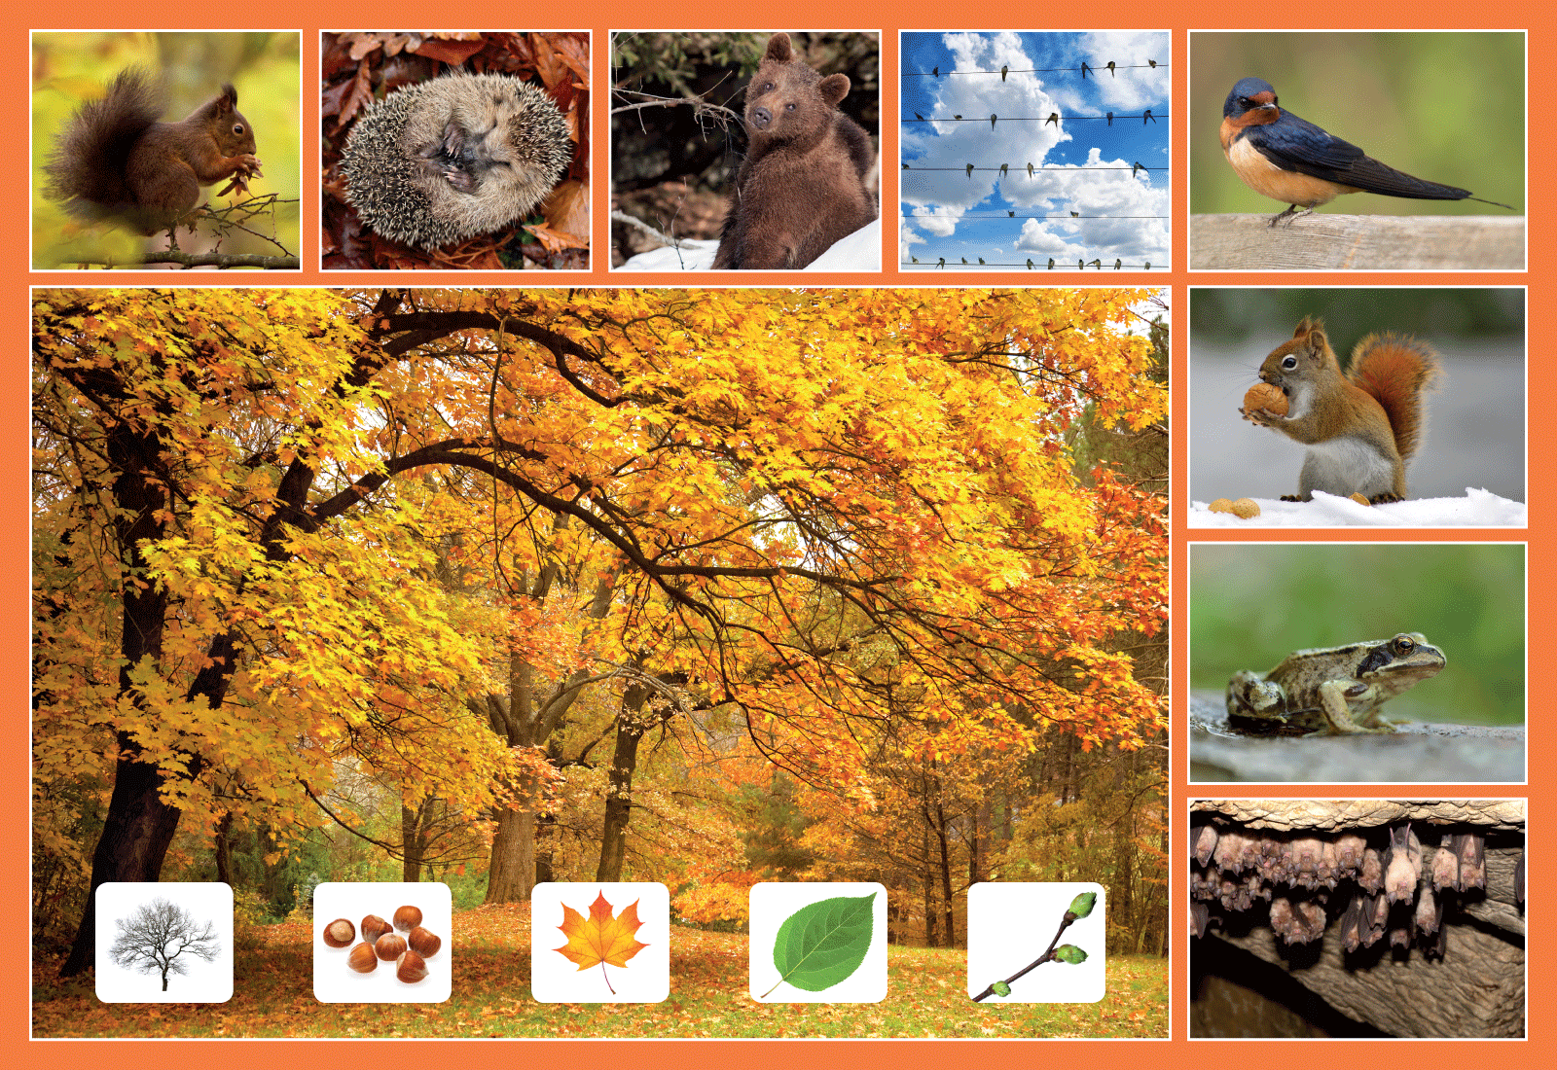
Class | Senior Infants | Theme | The world around us
Unit | 3 | Subtheme | Animals that hibernate
Vocabulary | Tier 1 examples: autumn, winter, spring, summer, squirrel,  hedgehog, mouse, nest, frog, bear, bat, bird, swallow, nuts,  leaves, cave  Tier 2 examples: hazelnut, upside-down, shoots, maple leaf  Tier 3 examples: hibernate, migrate, underneath
Lesson resources | Hibernation or migration? sheet, multimedia links
Element | Learning outcome | The child should be able to …
Communicating | LO 1 | Listen to and enjoy poems and finger rhymes.
 | LO 2 | Demonstrate good control of volume and intonation.
Understanding | LO 4 | Express and understand complex sentence structures including prepositions, e.g. underneath and conjunctions, e.g. because.  Understand morphological growth, e.g. adding ‘-or’ onto the ends of words.
 | LO 5, 6 | Use a wide range of nouns and verbs to explore the poster scene including synonyms, e.g. snug, cosy, toasty, comfy; similes, e.g. as snug as a bug in a rug; rhyming words, e.g. more/snore.
Exploring and using | LO 9 | Ask and answer a variety of open and closed questions, including ‘wh’ questions.
 | LO 10 | Categorise vocabulary relating to autumn.
 | LO 11 | Retell a familiar story to other children (Goldilocks and the Three Bears).
 | LO 12 | Use language playfully and creatively in response to a poem, e.g. by adding new lines.
 | LO 13 | Report characteristics of animals that hibernate/migrate

Fortnightly plan
Lesson 1 | Digital poster (Story mode)  Digital poster (Explore mode): Talk and discussion  Sing and say  Poem: Bed-Time  When, where, why? | Lesson 3 | Digital poster (Explore mode): Talk and discussion  Digital poster (Activity mode) – Multiple-choice questions  Let’s introduce ourselves!  Same and different  Freeze chant  ‘Hibernation’ song
Lesson 2 | Digital poster (Story mode) – Recap  Digital poster (Question mode)  Storytime: Bear Snores On  Pair talking task: What’s my name? | Lesson 4 | Digital poster (Label mode)  Digital poster (Poem mode): Furry Bear  Report: Hibernation or migration?

Lesson 1
Digital poster (Story mode) LO 1
Play either the Story mode 1 (starters) or Story mode 2 (flyers) for the class, depending on the ability level.

Digital poster (Explore mode): Talk and discussion LO 4, 5, 6, 7, 10, 14
Go to the Explore mode of the poster. Zoom in on the dormouse.

Ask children the following questions:
- Can you see the hedgehog on this poster?
- Where is it? (Encourage children to locate on the poster using language, without pointing – e.g. he is in the picture at the top of the poster between the brown bear and the bird).
- What is it doing? (curling up, sleeping)

Now show the class this video of a dormouse snoring while hibernating https://www.youtube.com/watch?v=DlS3w1GGE8g and ask the following questions:
- What kind of animal is this?
- What is happening in the video?
- Why is the dormouse snoring so loudly?
Introduce the word hibernate. Explain that this refers to when an animal goes to sleep for a very long time when the cold weather comes in autumn. All the animals on the poster are animals that hibernate.
Definition: Sleep during winter; be in an inactive or dormant state http://dictionary.kids.net.au/word/hibernate
Now ask children to carry out the following tasks:
- Name the animals (squirrel, hedgehog, brown bear, dormouse, bat, snail, frog)
- Locate where the animals are on the poster (beside, above, underneath, between)
- Talk about where the animals live/what the animals eat/ how the animals prepare to hibernate.
- Talk about the season (autumn, colours, leaves, nuts)

Sing and say LO 1, 12
Play the song, ‘I Can’t Wait to Hibernate’ by Brent Holmes for the class: https://www.youtube.com/watch?v=MHAQN5wf4vg
Encourage children to sing along with the chorus.
Now ask children to say what they learned from the song using the following ‘wh’ questions:
- What words can you hear that rhyme in the song? (wait, hibernate, great; more, snore)
- When does the bear hibernate?
- Why does the bear hibernate?
- Where does the bear go to hibernate?
- What story does Bear read before he goes to sleep? Why do you think he likes this story?

Next, ask children the following:
- Can you retell the story of Goldilocks and the Three Bears? (this can be facilitated by the teacher as a whole-class activity followed by shared retelling by children in pairs. Pictures may be used as scaffolding for this activity if appropriate).
- What is the difference between sleeping and hibernating? (body temperature drops, rate of breathing slows down) What kind of sleep does a hibernating animal have? (a deep sleep) Can you think of any other words that have a long ‘ee’ sound in them? (bee, deer, feel, keep, sweep, sheep, week, feet, heel, knee)
- In the song, Bear talks about going to sleep. Can you remember any of the words that Bear uses that remind us of sleeping/going to bed? (tuck myself in; pillow; fluff it up)
- How do you think Bear feels when he is hibernating? (Synonyms for comfortable – snug, cosy, toasty, comfy, cuddled up, sheltered, curl up, snuggle)
- Introduce the simile ‘as snug as a bug in a rug’.
- How do you feel when you are in your cosy bed?
- What makes you cosy in bed?
- What do you take to cuddle in bed?

Poem: Bed-Time LO 1, 12
Read the poem Bed-Time to the class, then read it again and ask the children to join in quietly where they can.

Bed-Time
By John Kitching

Bed-Time, Bed-Time
Hot milk, honeyed-bread time,
Favourite book to read time,
Best rhymes to be said time,
Stairs quietly tread time,
Cosy bedspread time,
Cuddle with Ted time,
Eyes heavy as lead time,
Sleepy old head time.
Bed-Time, Bed-Time.

Can you add another line before the very last line about when you are going to bed?
e.g. snug as a bug in a rug time, comfy and toasty and snug time, hugging my favourite toy time, snuggling softly with Mum/Dad time, etc.

When, where, why? LO 9
Organise children in pairs. Have them turn to their partners and ask a ‘wh’ question about animals that hibernate, e.g. where do bears like to hibernate? When do hedgehogs go to sleep? Once the question has been answered, children swap roles and repeat.

Lesson 2
Digital poster (Story mode): Recap
Play either the Story mode 1 (starters) or Story mode 2 (flyers) for the students again. Make sure they understand all of the vocabulary.

Digital poster (Question mode) LO 8, 9, 13, 14
Go to the Question mode of the poster. Listen to each question and discuss the answers with the children briefly.

Q1. | What colours are autumn leaves?
Q2. | What do squirrels like to eat?
Q3. | Where do bats sleep?
Q4. | How do hedgehogs build up their body fat in the autumn?
Q5. | Where do you think squirrels hide their food?
Q6. | Why do some animals migrate from one place to another?
Q7. | Where do swallows fly to in the autumn?
Q8. | If you were a bird where would you migrate to?
Q9. | Animal experts say you shouldn’t wake a bear when it’s hibernating. Why do you think this is?
Q10. | Which season is your favourite? Why?

Storytime LO 1, 5, 6, 12
Listen to the story of Bear Snores On by Karma Wilson: https://www.youtube.com/watch?v=L4AemrqBQCo
Ask children the following questions:
- Do you think this is a true story?
- What is in the story that is true about what bears do in winter?

Pair talking task: What’s my name? LO 5, 12
Have children think of a name for each animal in the poster, making sure it begins with the same sound as the animal, e.g. Harry Hedgehog, Bella Bear, etc.

Lesson 3
Digital poster (Explore mode): Talk and discussion LO 4, 5, 6, 7, 10, 14
Go to the Explore mode with children again. Focus on the birds in the poster, asking children the following questions:
- Which pictures show us birds in the poster? (e.g. There are birds in the two pictures on the top row on the right-hand side).
- Do birds hibernate?
Explain to the children that birds travel long distances to escape the cold, harsh winter. They go in search of food and warm shelter. We stay warm in winter with coats, scarves, hats, gloves and warm shoes or boots. Birds turn their feathers into puffy warm coats and some birds fly to warmer areas to stay warm and find food.
Introduce the word Migrate. Definition: the periodic passage of groups of animals (especially birds or fishes) from one region to another for feeding or breeding http://dictionary.kids.net.au/word/migration

Explain to children that an animal that hibernates is called a hibernator; a bird or fish that migrates is called a migrator; an animal that tries to prey on another animal is called a predator. Watch ‘Hibernation – The Dr. Binocs Show’ to further explore the vocabulary around hibernation: https://www.youtube.com/watch?v=FonCq9YJJxw

Digital poster: Multiple choice questions LO 1, 13
Go to the Activity mode of the poster and play the multiple choice questions. In each question, children must identify the animal that hibernates. Briefly discuss the answers with the class.

Hedgehog, deer, dog
Lion, dolphin, bear
Cow, bat, rabbit

Let’s introduce ourselves! LO 2, 13
Have children take on the role of one of the animals in the poster and introduce themselves, first to their partner and then to the rest of the class, e.g. Hello/Good morning/Good afternoon. My name is … Bat/Bear/Hedgehog/Bird. I am … I like to …

Same and different LO 4, 13
Ask children to explain the similarities and differences between the different animals on the poster. Scaffold the children by starting the sentence and then having them complete it in pairs, before sharing their observations with the class, e.g.:
- A bat and a bear are the same because … they both hibernate, they both live in caves.
- A bat and a bear are different because … a bat can fly and a bear can’t, a bat is small and a bear is big.
Freeze chant LO 2, 4, 5, 6
Have the children move around the room. As they do so, call out the phrase, ‘an animal that hibernates is called a hibernator’. Children repeat the phrase, putting their hands together at the side of the face to signify sleeping. Next, call out the phrase, ‘a bird that migrates is called a migrator.’ Children repeat the phrase, moving their arms up and down to signify flying. Teacher calls out the phrase. ‘an animal that preys on others is called a predator’. Children repeat the phrase, raising arms to signify an attack.

Listen to the ‘-or’ sound at the end of the words. Explain to the children that we use this sound for a person or a thing who/that does something, e.g. sailor; actor; visitor; decorator; editor; doctor; author; supervisor, etc.

‘Hibernation’ song LO 2, 4, 5, 6
Sing the song Hibernation for the class – to the tune of Alouette. Encourage children to sing along.

Hibernation, time for hibernation.
Hibernation, time to go to sleep.
In the winter where’s the bear?
Sleeping in its log or lair.
Where's the bear? Log or lair. OH!
In the winter where’s the frog?
Sleeping by a pond or log.
In the winter where’s the snake?
In the mud beneath the lake.
In the winter where’s the bat?
In a cave is where it’s at!
Hibernation, time for hibernation,
Hibernation, time to go to sleep.

Lesson 4
Digital poster (Label mode) LO 6, 7
Go to the Label mode of the poster. Review the vocabulary. Have students take turns dragging the labels onto the correct location in the poster.

Digital poster (Poem mode): Furry Bear LO 12
Go to the Poem mode of the poster and play the poem Furry Bear by A.A Milne:

Furry Bear
By A. A. Milne

If I were a bear,
And a big bear too,
I shouldn’t much care
If it froze or snew;
I shouldn’t much mind
If it snowed or friz--
I'd be all fur-lined
With a coat like his!
For I’d have fur boots
and a brown fur wrap,
And brown fur knickers
and a big fur cap.
I’d have a fur muffle-ruff
to cover my jaws.
And brown fur mittens
on my big brown paws.
With a big brown furry-down
up to my head,
I’d sleep all the winter
in a big fur bed.

Have children join in with reading the poem. Encourage them to speak with appropriate intonation and expression. Children could perform actions to go with each item of ‘clothing’ described in the poem (wrapping up in a fur wrap, putting on their fur mittens, etc.)

Hibernating bear fingerplay
Teach children the fun hibernation fingerplay, ‘hibernating bear’:

Here is a cave (bend fingers to form cave)
Inside is a bear (put thumb inside fingers)
Now he comes out (thumb out)
To get some fresh air.
He stays out all summer
In sunshine and heat.
He hunts in the forest
For berries to eat. (move thumb in circle)
When snow starts to fall (waggle fingers of other hand to show snow falling)
He hurries inside
His warm little cave (thumb in)
And there he will hide.
Snow covers the cave
Like a fluffy white rug (cover with other hand)
Inside the bear sleeps
All cozy and snug.

Report: Hibernation or migration? LO 13
Organise children in pairs. Give each pair one copy of the hibernation or migration sheet (see Lesson resources 1).

Pairs should decide which pictures go in each column and take turns to draw the pictures in the correct column. Encourage children to report their answers to another pair or to the rest of the class.

e.g. A brown bear hibernates. While he is hibernating, he curls up tight and he sleeps in a cave. His body temperature drops. Before he hibernates, he stores up food to eat.

Lesson resource 1
Hibernate Migrate
