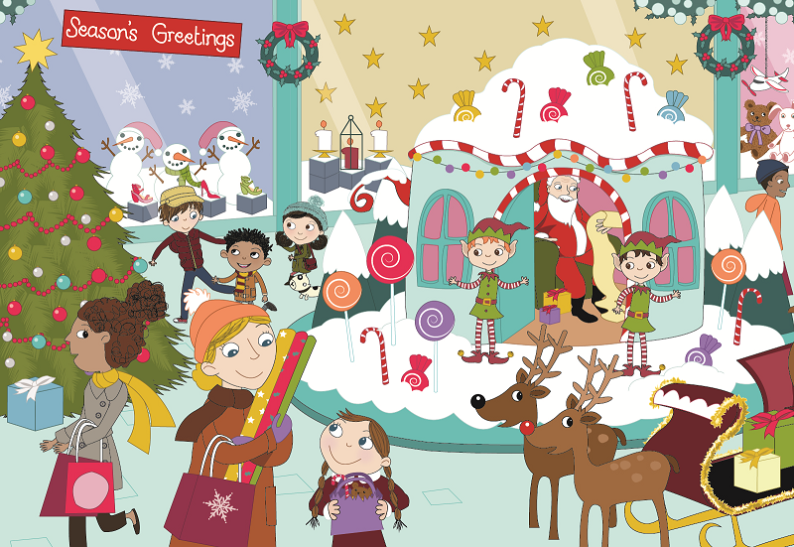
Class | Senior Infants | Theme | Shopping
Unit | 7 | Subtheme | The shopping centre
Vocabulary | Tier 1 examples: Christmas tree, snowman, presents,  reindeer, wrapping paper, decorations, etc.  Tier 2 examples: sleigh, grotto, candy cane  Tier 3 examples: tunic, buckle, trimmed
Lesson resources | Photocopiable: Snowman outline drawing
Element | Learning Outcome | Learning Objective (The child will be enabled to …)
Communication | LO 1 | Listen to new information
 | LO 2, LO 3 | Initiate and take turns in conversation with teacher and peers  Work in pairs/groups to problem-solve
Understanding | LO 4 | Use complete sentences, plurals (note plural of ‘reindeer’), prepositions (e.g. on top of; between; in front of) and some basic connectives (e.g. but; because)
 | LO 5, LO 6 | Acquire and understand new vocabulary and phrases from a story Understand and use nouns, adjectives, verbs, adverbs, compound words (e.g. snowflake; workshop)
 | LO 7 | Show understanding of a story  Follow instructions
 | LO 8, LO 9 | Ask and respond to simple questions
 | LO 10 | Name and categorise objects
Exploring and using | LO 12 | Listen and respond to poetry
 | LO 13 | Name and describe objects and people  Give instructions
 | LO 14 | Describe and interpret other people and their feelings/behaviour

Fortnightly plan
Lesson 1 | Digital poster (Story mode)  Digital poster (Explore mode) – talk and discussion  Pair talking task – Santa’s list | Lesson 3 | Digital poster (Explore mode) – talk and discussion  Digital poster (Activity mode) – spot the difference  Odd one out
Lesson 2 | Digital poster – recap  Digital poster (Question mode)  Barrier game – dress the snowman | Lesson 4 | Digital poster (Label mode)  Digital poster (Poem mode) – A Shy Santa  Describe Santa

Lesson 1
Digital poster LO 1
Play either the Story mode 1 (starters) or Story mode 2 (flyers) for the class, depending on the ability level.

Digital poster: Talk and discussion LO 4, 5, 6, 7, 10, 14
Go to the Explore mode of the poster. Ask students the following questions:

- Look at the snowmen in the shop window. Which one is different? Why? The snowman in the middle is different because he is smaller than the other snowmen, he has no hat, and he is wearing a green scarf.
- Look at the candles in the shop window. Which one is different? Why?
- Can you see something stripy; swirly; pointy; bright; shiny; red; white, etc. in the poster?
- Can you see something high/low; wide/narrow; tall/short; open/closed; light/heavy, etc. in the poster?
- Look at the elves. Describe what they are wearing. They both have green tunics, red and white striped tights/leggings, pointy shoes with curly toes and bells on each shoe, red belts with gold buckles, pointy hats trimmed with green.
- Can you find something in the poster that rhymes with log (dog), boy (toy), cake (flake), cheer (deer), lift (gift)?
- Everyone in the poster is happy. How do we know they are happy? Do you think the children are happier than the grown-ups? Why? Who do you think is the happiest of all in the picture? Why?

Remember: the aim is to name as many items associated with Santa and Christmas as possible.

Nouns Use the spotlight tool to focus on different items as they are named. Use the pen tool to categorise the various items after they have been named, e.g. circle all the items on the poster that are toys, shops, presents, sweets, people, animals, winter clothes, packaging (shopping bag, carrier bag, box), decorations (wreaths, shiny Christmas baubles, holly, tinsel, candy cane, ornaments, bell, angel, star, snowflake, stocking, candle).
Describe the various items using increasingly complex syntax.
Verbs, e.g. shop, choose, wrap, unwrap, tie, write, post, give, get, hang, decorate, prepare, eat, drink, sing
Adverbs, e.g. merrily, joyfully
Adjectives, e.g. amazing, multicoloured, magical, fluffy, enormous.

Listen to the song Must be Santa on YouTube (https://www.youtube.com/watch?v=42_vCV2_gf0). How many describing words can you hear? (e.g. red, long, white, big, special, amazing, multicoloured, naughty, nice, bright, fluffy)

Pair talking tasks: Santa’s list LO 2, LO 3
Tell students the following:

‘Santa is reading his list in his grotto.
One child is on the naughty list. His name is Alan.
Can you tell Santa why Alan was put on the naughty list?
Is there anything that Santa can do to get Alan off the naughty list in time for Christmas?’

Tell students to share their solution with another pair.

Lesson 2
Digital poster: Recap
Play either the Story mode 1 (starters) or Story mode 2 (flyers) for the students again. Make sure they understand all of the vocabulary.

Digital poster LO 8, 9, 13, 14
Go to the Question mode of the poster. Listen to each question and discuss the answers with the children briefly.

Q1. | Where are Kate, Jack and Mark?
Q2. | What is on top of the Christmas tree?
Q3. | Who are Kate and Mark on their way to see?
Q4. | Do you think Santa’s elves enjoy working at the grotto? Why?
Q5. | What does Mark think of the Christmas tree? How can you tell?
Q6. | Why do you think Santa chose sweets and lollipops to decorate his grotto?
Q7. | How do you think Kate and Mark are feeling about meeting Santa?
Q8. | What do you think Rocky will do when he sees the reindeer?
Q9. | Do you think Jack is a nice big brother? Why do you think that?
Q10. | What would you say to Santa if you visited his grotto?

Next, go to the Explore mode of the poster and spotlight the reindeer. Teacher models questioning interaction with one child at the top of the room (teacher asks a question and the child answers). Next, encourage the child to ask the teacher a question. Have one child come up in front of the class and get them to model asking a question about the reindeer. Encourage all the children to work in pairs asking and answering questions, e.g. ‘What colour is the reindeer’s nose? How many legs has the reindeer? Which is your favourite reindeer? What do we call the reindeer horns?’

Barrier game: Dress the snowman LO 7, 13
Group the children in pairs. Give each pair an outline drawing of a snowman without any eyes, nose, hat, etc.
Child A gives instructions to Child B to draw facial features and clothes on the snowman, e.g. ‘Draw a tall black hat on the snowman’s head.’ ‘Give the snowman a long orange carrot for a nose’, etc. Child B then gives instructions to Child A to do the same thing. Each pair should then compare results.

Lesson 3
Digital poster: Talk and discussion LO 5, 6
Go to the Explore mode with students again. Focus on:

Plurals – words that sound the same in the singular and plural (reindeer; Lego; fish; sheep); elf/elves; hoof/hooves; scarf/scarves; box/boxes; wish/wishes)
Opposites – naughty/nice
Comparative and Superlative – happy, happier, happiest
Rhyming words – words that sound similar (elf – self, shelf, myself)
Prepositions – decorations on the tree; presents under the tree; Santa in the grotto; shoes in the window display; star on top of the tree; candy cane over the door; red candle between the two white candles; elves outside the grotto; reindeer in front of the sleigh
Synonyms – e.g. gift/present; happy – jolly/glad/delighted/cheerful/thrilled
Compound words – snowman, snowball, snowflake, snowfall, workshop, reindeer, gingerbread, peppermint, starlight, fruitcake, fireplace, pinecone

Digital poster: Spot the difference LO 2, 13
Go to the Activity mode of the poster and display the two images. Ask the children to work in pairs to identify differences. Encourage the children to identify and explain the differences to the class.

Remember: It is important to encourage the children to use language rather than pointing, e.g. ‘The mum is wearing a red hat in one picture and a yellow hat in the other picture OR in the picture on the left/the picture on the right.’

Odd one out LO 10, 13
Tell the children they are going to play the game ‘Which is the odd one out?’ Name four items (e.g. snow, frost, icicles, sunshine) and ask children to find and explain the odd one out.

Lesson 4
Digital poster LO 6, 7
Go to the Label mode of the poster. Review the vocabulary. Have students take turns dragging the labels onto the correct location in the poster.

Digital poster: A Shy Santa LO 12
Go to the Poem mode of the poster and play the poem:

A Shy Santa
Isn’t it the strangest thing,
That Santa is so shy?
We can never, never catch him,
No matter how we try.
It isn’t any use to watch,
Because my parents said,
Santa Claus will only come
When children are in bed!'

Describe Santa LO 13
Tell the children that they are going to have fun describing Santa. Say ‘Isn’t it the strangest thing that Santa is so … fat; old; big; jolly; hairy, etc. Have children take turns finishing the line. Then ask them to draw a shy; jolly; big, etc. Santa.

