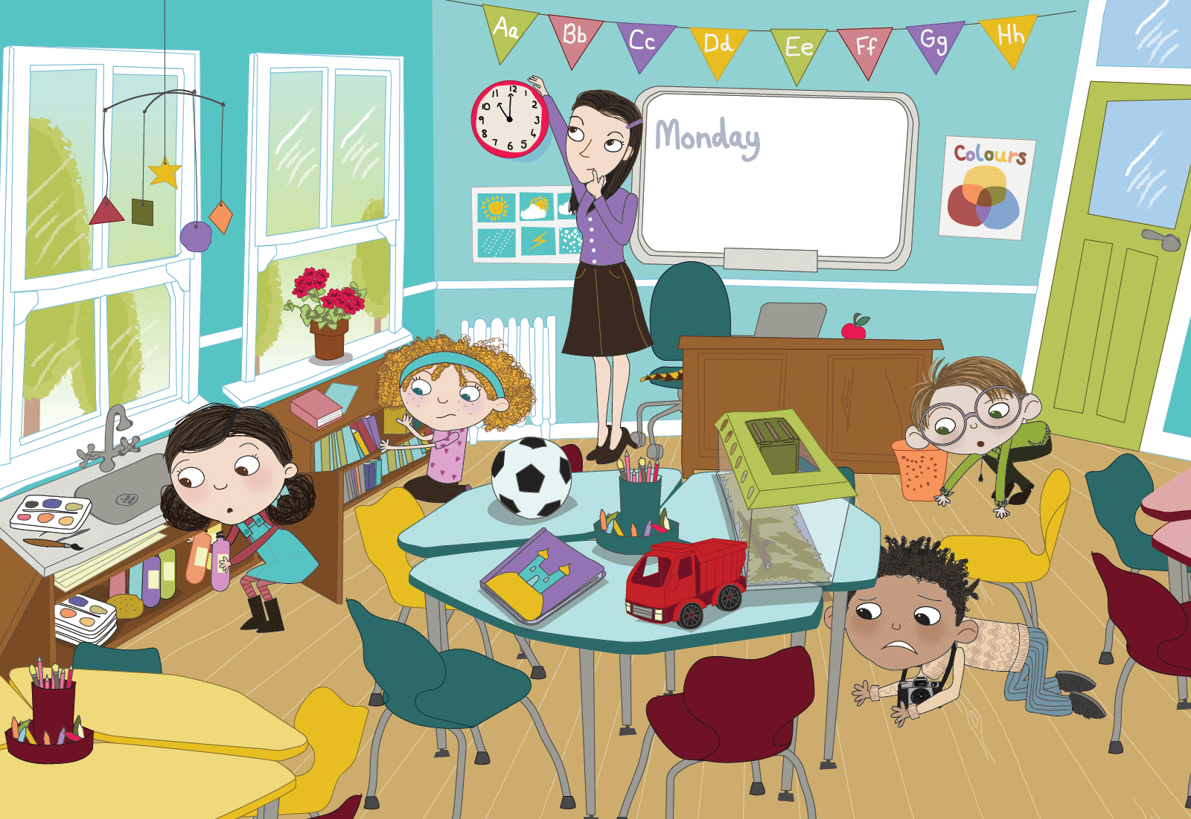
Class | Junior Infants | Theme | School
Unit | 10 | Subtheme | My classroom
Unit genre | Recount
Vocabulary | Tier 1 examples: snake, missing, between, worried, nervous, cupboard  Tier 2 examples: slid, escaped, anxious, library, bending, hiding, aside  Tier 3 examples: slithered, peering, terrified, nervously
Lesson Resources | Multimedia links
Element | Learning Outcome | The child should be able to …
Communicating | LO 1 | Listen to new information and vocabulary about the classroom.
 | LO 2, LO 3 | Initiate, sustain and engage in conversations on the classroom theme.  Work collaboratively with others and share discussions and findings with others.
Understanding | LO 4 | Use prepositions to describe where an item/person is in relation to other things (under, on top of, beneath, etc.).
 | LO 5, LO 6 | Develop and use a wide variety of vocabulary based on the classroom theme.
 | LO 7 | Demonstrate understanding through following instructions, answering questions and participating in various exercises.
Exploring and using | LO 8, LO 9 | Ask and respond to simple questions.
 | LO 10 | Name, describe and categorise people and objects, thus demonstrating a deeper understanding.
 | LO 11 | Tell and retell stories and personal narratives of increasing length and complexity.
 | LO 12 | Listen and respond to a poem and explore the creative aspects of language.
 | LO 13 | Deliver information, and explain and justify points using topic-specific language and evidence.
 | LO 14 | Describe themselves, their classroom and other people using the topic-specific vocabulary.

Fortnightly plan
Lesson 1 | Digital poster (Story mode)  Digital poster (Explore mode): Talk and discussion  Pair/group talking task: ‘I Spy’ | Lesson 3 | Digital poster (Story mode): Recap  Digital poster (Question mode)  Digital poster (Activity mode): Spot the difference  Oral recount
Lesson 2 | Digital poster (Story mode): Recap  Digital poster (Explore mode): Talk and discussion  Pair/Group talking task: ‘I Spy’  Where is it? | Lesson 4 | Digital poster (Label mode)  Digital poster (Poem mode): ‘Undertable Land’  Draw your own Undertable Land

Lesson 1
Digital poster (Story mode) LO 1
Play either the Story mode 1 (starters) or Story mode 2 (flyers) for the class, depending on the ability level.

Digital poster: Talk and discussion LO 4, 5, 6, 7, 10, 11, 14
Go to the Explore mode of the poster Jake the Snake. Use the tools to explore the poster. Ask the following questions:
- What room is this? (A classroom) How do you know it is a classroom? It has furniture: desks, chairs, bookshelves, etc.; equipment: bin, clock, laptop/computer, etc.; materials: art materials, paint, paintbrushes, etc.; stationery: pencils, crayons, etc.; decorations: posters, mobile, plant, etc.
- What day of the week is it? How do you know? What sound does that word begin with?
- Can you see anything else in the picture that starts with an ‘m’ sound? mobile, mouth
- What have we in our classroom that is not in this classroom?
- What is in this classroom that you would like to have in our classroom? (e.g. a truck) Why?
- Do you think any of the people in the picture are staring/glancing?
Aim to name as many items as possible. Use the highlight tool to highlight each item as it is named.
Describe the various items using increasingly complex syntax, e.g. ‘this classroom has a large desk for the teacher with an apple on it for the teacher’s lunch; it has a white radiator to heat up the classroom when the weather is cold in the winter.’

Categorical terms: Use the highlight tool to categorise the various items after they have been named, e.g. highlight all the items on the poster which are ‘furniture’.

Listen to the Where is it? song on YouTube (https://www.youtube.com/watch?v=8F0NYBBKczM). Ask the children questions about where things are positioned in the poster and in their own classroom. Point out the following: ‘When we are searching we are using our eyes. We could also say that we are looking. If we look for a long time, we are staring. If we look very quickly, we are glancing.’

Return to the poster. Ask the children: Where is Kate looking? (in the cupboard) Where is Mark looking? (under the desk) Where is Anna looking? (between the books) Where is Cian looking? (beside the bin) Where is Miss Sharpe looking? (above the clock)

Pair/group talking task: ‘I Spy’ LO 4, 5, 6, 13
Model an ‘I Spy’ game with one of the children.

Teacher: I spy with my little eye a piece of furniture that you sit on in the classroom; Child: You spy a chair! Teacher: I spy with my little eye some decorations that hang from the ceiling; Child: You spy a mobile!

Get children to play the game in pairs. Encourage them to label, describe and locate objects using increasingly complex syntax.

Lesson 2
Digital poster (Story mode): Recap LO 1
Play either the Story mode 1 (starters) or Story mode 2 (flyers) for the children again. Make sure they understand all of the vocabulary.

Digital poster (Explore mode): Talk and discussion LO 4, 5, 6, 7, 10, 11, 14
Focus on the poster again this time, with reference to the location of various objects around the classroom. For example: The truck is on the table beside the tank. The poster is on the wall beside the door. The teacher is looking above the clock that is over the radiator. Other possible vocabulary items to include here: under, underneath, on top of, inside, through, beneath, next to, to the left of, to the right of, over by, in, hanging from, etc.

Pair/group talking task: ‘I Spy’ LO 4, 5, 6, 13
In pairs, get the children to revisit the game of ‘I Spy’, this time trying to use as many words associated with location as possible. For example: ‘I spy with my little eye something that is on top of the library shelf to the right of the door.’

Where is it? LO 4
Sing the Where is it? song again (https://www.youtube.com/watch?v=8F0NYBBKczM)
Give one child an object to hide. Close your eyes while the child hides the object.
Ask questions while the children sing the Where is it? song, e.g. Is it in; on; under; between; beside …?
Repeat.
Then hide an object while the children close their eyes. The children ask questions while singing the song – is it in; on; under; between; beside; above …? etc.

Note: This activity may be completed in pairs later on.

Lesson 3
Digital poster: (Question mode) LO 7, 13, 14
Go the to the Question mode of the poster. Listen to each question and discuss the answers with the children briefly.

Q1. | Where are the children?
Q2. | What are they doing?
Q3. | Where are the teacher and children looking?
Q4. | What is Kate doing with the paint bottles? Why is she doing this?
Q5. | How is Anna feeling? Why is she feeling this way?
Q6. | Who is feeling nervous? How can you tell?
Q7. | Can you find Jake in the picture? How do you know he is there?
Q8. | Do you think that Mark is brave? Why?
Q9. | Why do you think no one can see Jake?
Q10. | Would you like if there was a snake slithering around your classroom? Why or why not?

Digital poster (Activity mode): Spot the Difference LO 2, 13
Go to the Activity mode of the poster and display the two images. Ask the children to work in pairs to identify differences. Encourage the children to identify and explain the differences to the class.
Remember: It is important to encourage the children to use language rather than pointing, e.g. ‘Kate has bottles of paint in her hand in one picture, but not in the other’.

Oral recount LO 11
Have children orally recount events. The events can be of increasing complexity in order to encourage the use of more sophisticated language.

Level 1 | Ask the children to share stories of when they first came to school and how it felt. Model this with the children first.
Level 2 | Ask the children to describe a time when something happened at school (e.g. one day I forgot my lunch/schoolbag/coat; one day I was playing at school and ...; one day at school I really liked my Art/PE/Gaeilge lesson because …; one day at school my friend played XXX with me/shared XXX with me. That made me feel …
Level 3 | What would you do if a snake broke loose in the classroom? (Describe, locate, recount)
Lesson 4
Digital poster (Label mode) LO 6, 7
Go to the Label mode of the poster. Review the vocabulary. Have the children take turns dragging the labels onto the correct position in the poster.

Digital poster (Poem mode): Undertable Land LO 12
Go to the Poem mode of the poster and play the poem ‘Undertable Land’ by Paul Rogers:

Undertable Land
By Paul Rogers

Daddy’s baggy trousers,
Grandma’s bony knees,
Tommy’s lost a slipper,
Someone’s dropped some cheese.

Chair legs, their legs, table legs,
The hairs on Grandpa’s hand …
No one knows what I can see,
In Undertable Land

Up above the table top,
Chatter and clatter of tea.
Down here, invisible,
No one else but me.

Listening to what they say …
Some I understand.
But I know all there is to know
In Undertable Land.

Ask the children the following questions about Undertable Land:

- What meal do you think it is? Why?
- Who is sitting at/under the table?
- What can be seen in Undertable Land?
- How many types of legs are there? How are they the same/different?
- Have you ever visited Undertable Land? When/Why/What did you see/hear/smell/touch?
- Is it better there? Why?

Draw your own Undertable Land LO 12
Either on their own, or in pairs, ask the children to draw a picture of Undertable Land in their house. Give them examples of things they might see, e.g. crumbs scattered, baby toes, spilt drink, purring cat, hungry dog, legs crossed, fluffy socks, etc. Children draw their picture and explain it to their partner or to the class.

