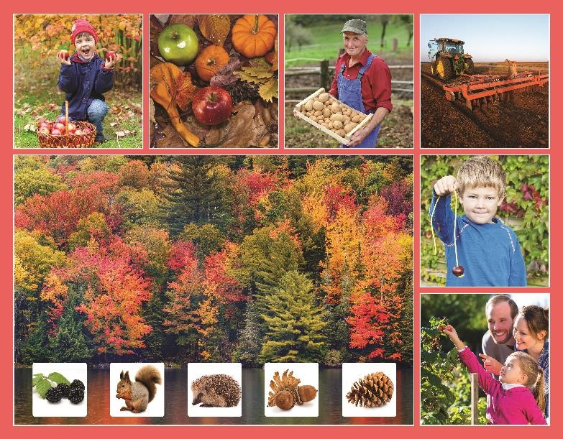
Class | Junior Infants | Theme | The world around us
Unit | 3 | Subtheme | Autumn
Vocabulary | Tier 1 examples: tree, leaf, colour, fruit, apple, farmers  Tier 2 examples: blackberry, acorn, carve, conker, berries,  seeds, squirrel, hedgehog  Tier 3 examples: delicious, crunchy, sweet, juicy, nibble, pine cone, plough, harvest, hibernation
Lesson resources | Multimedia links
Element | Learning outcome | The child should be able to …
Communicating | LO 1 | Listen to new information.
 | LO 2, LO 3 | Initiate, sustain and engage in conversations on the theme of autumn.  Work collaboratively with others and share discussions and findings with others.
Understanding | LO 4 | Use complete sentences, plurals (e.g. leaves; berries; potatoes) prepositions (e.g. on top of; between; in front of) and some basic connectives (e.g. but; because)
 | LO 5, LO 6 | Acquire and understand new vocabulary and phrases from a story.  Understand and use nouns, adjectives, verbs, adverbs and compound words (e.g. hedgehog; blackberry; farmyard).
 | LO 7 | Show understanding of a report on autumn.  Follow instructions.
Exploring and using | LO 8, LO 9 | Ask and respond to simple questions on a report.
 | LO 10 | Name and categorise objects based on the autumn theme.
 | LO 11 | Tell and retell stories and personal narratives of increasing length and complexity.
 | LO 12 | Listen and respond to a poem.  Explore creative language use by creating a simple poem with a partner.
 | LO 13 | Name, describe and categorise people and objects.  Demonstrate an understanding of categorical terms.  Give instructions.
 | LO 14 | Describe and interpret other people and their feelings/behaviour.

Fortnightly plan
Lesson 1 | Digital poster (Story mode)  Digital poster (Explore mode): Talk and discussion  Pair talking task: Can you remember? | Lesson 3 | Digital poster (Activity mode): Multiple choice questions  Digital poster (Explore mode): Talk and discussion  Compound words  Digital poster: Picture puzzlers  Turn and tell, then stand and share: Would you rather?
Lesson 2 | Digital poster (Story mode): Recap  Digital poster (Question mode)  Finish the sentence  Autumn finger play | Lesson 4 | Digital poster (Label mode)  Digital poster (Poem mode): ‘Noisy, Noisy’  Storytime  Paired poem construction

Lesson 1
Digital poster (Story mode) LO 1
Play either the Story mode 1 (starters) or Story mode 2 (flyers) for the class, depending on the ability level.

Digital poster (Explore mode): Talk and discussion LO 4, 5, 6, 7, 10, 14
Go to the Explore mode of the poster.

Use the photographs as starting points for a whole class brainstorm on the topic of Autumn. Introduce the words autumn and season, e.g. Autumn is a season that comes after summer. A season lasts for a long time, longer than a day or a week. Lots of things around us change in autumn. Let’s look at the poster to see what changes show us that autumn is coming.

Use the spotlight tool to focus first on the largest picture – changes in the trees. Ask children the following questions:
- What can we see? (Trees)
- What do we call one of them? (a tree)
- What grows on a tree? (Leaves)
- What do we call one of them? (A leaf)
- Different kinds of trees have different kinds of leaves. Compare and contrast samples of leaves for size, shape, colour, etc. What colour are the leaves in summer? (green)
- What do you notice about the trees in our picture? (Different colours)
- What part of the tree is changing colour? (Parts of a tree – leaves)
- What colours can you see? (Red; yellow; orange; brown)
- Can you name the parts of the tree that don’t change colour? (Parts of a tree – trunk; branches)
- What happens in autumn that makes the leaves change colour? (Leaves change colour because their food runs out in the autumn)
- What happens to the leaves after they turn brown? (They fall from the trees)
Continue discussing the other signs of autumn seen on the poster.

Pair talking task: Can you remember? LO 2, 3
Organise the children into pairs. Have one child in each pair turn their back to the board and try to remember all that they have seen on the board about autumn. They have 60 seconds to tell their partner everything they can recall about autumn. The partner can give hints if the child gets stuck by describing one of the pictures. When the 60 seconds are up, the partners swap places and begin again.

Lesson 2
Digital poster (Story mode): Recap LO 1
Play either the Story mode 1 (starters) or Story mode 2 (flyers) for the children again. Make sure they understand all of the vocabulary.

Digital poster (Question mode) LO 8, 9, 13, 14
Go to the Question mode of the poster. Ask children to listen to each question. Discuss the answers with the class briefly.

Q1. | What season is it?
Q2. | What colours are the leaves?
Q3. | What fruit and vegetables can you see?
Q4. | What does the farmer do on the land at this time of year?
Q5. | Why are pumpkins popular at Halloween?
Q6. | What do squirrels do during autumn? Why do they do this?
Q7. | Why do hedgehogs eat as much food as they can during autumn?
Q8. | Do you know what kind of tree an acorn comes from?
Q9. | Do you know another word for autumn?
Q10. | Do you think autumn is a nice time of year? Why do you think that?

Finish the sentence LO 4, 11
Ask the children to look at the poster carefully. Then ask them to complete these sentences:
- The boy is happy because …
- The squirrel is …
- We make … out of pumpkins.
- Three signs of autumn that I can see are …
- The tractor is …
- My favourite picture is … because …
- I like … and … because …
- The little girl is … for …
- The red/brown/orange things I can see are …

Autumn finger play LO 7, 12
Chant the finger play below, encouraging children to join in and perform the actions.

Autumn winds begin to blow (blow)
Coloured leaves fall fast and slow (move hands to show leaves falling)
Twirling, whirling all around (turn around a few times)
Until at last, they touch the ground (fall to the ground)
Follow this link for more suggestions of autumn activities: http://www.preschool-plan-it.com/fall-preschool-activities.html
Lesson 3
Digital poster (Activity mode): Multiple choice questions LO 2, 13
Go to the Activity mode of the poster and play the multiple choice questions. For each question, children must identify the picture which is associated with autumn. Briefly discuss the answers with the class.

Digital poster (Explore mode): Talk and discussion LO 5, 6
Go to the Explore mode with the children again. Focus this time on plurals.
List singular autumn nouns and ask the class to respond with the plural. e.g., one leaf, many leaves
- One tree, many … (trees)
- One branch, many … (branches)
- One tree trunk, many tree … (tree trunks)
- One apple, many …
- One pumpkin, many …
- One hedgehog, many …
- One squirrel, many …
- One pinecone, many …
- One blackberry, many …
- One conker, many …
- One potato, many …
Expand to focus on lf/ves plural sounds, e.g. calf/calves; hoof/hooves; knife/knives; loaf/loaves; leaf/leaves
Compound words
Explain to children that sometimes, we can put two small words together to make one longer word (compound words), e.g. scare + crow = scarecrow
Ask children if they can think of any other compound words to do with autumn, e.g. haystack; pinecone; blackberry; hedgehog; cornfield; farmyard, etc. Alternatively, give children the first half of the compound word and ask them to complete it.
Digital poster: Picture puzzlers LO 2, 13
Ask children to solve the following ‘picture puzzles’ using the clues below – the answers are all in the picture!

- I'm sometimes big and sometimes small. In the autumn, you see me fall (leaf)
- We’re round and brown and in a crate (potatoes)
- We grow into oak trees (acorns)
- This word rhymes with teaching (reaching)
- The farmer drives this machine (tractor; harvester)
- This is great for playing a cracking game (conker)
- I’m a red and juicy fruit (apple)
- You can make a lantern out of my shell (pumpkin)
- I have spikes and a pointy snout (hedgehog)
- I hide nuts for winter (squirrel)
- This word starts with a ‘p’ sound (pine cone; pumpkin)

Turn and tell, then stand and share LO 2, 3, 7, 11, 13
Would you rather?
Organise children into pairs and have them ask each other autumn-themed ‘Would you rather?’ questions, then have them share their answers, and their partner’s answers, with the class.

Would you rather:
- … go blackberry or apple picking?
- … hug a squirrel or a hedgehog?
- … have a pumpkin for a head or acorns for toes?
- … play with conkers or pinecones?
- … eat pumpkin pie or apple pie?

I would rather … because …
My partner would rather … because he/she …
Lesson 4
Digital poster (Label mode) LO 6, 7
Go to the Label mode of the poster. Review the vocabulary. Have the children take turns dragging the labels onto the correct location in the poster.

Digital poster (Poem mode): ‘Noisy, Noisy’ LO 12
Go to the Poem mode of the poster and play the poem ‘Noisy, Noisy’ by Jack Prelutsky:

Noisy, Noisy
By Jack Prelutsky

It’s noisy, noisy overhead,
The birds are winging south,
And every bird is opening
A noisy, noisy mouth.

They fill the air with loud complaint,
They honk and quack and squawk-
They do not feel like flying,
But it’s much too far to walk.

Storytime LO 1, 11, 14
Ask the children if they know what some birds do in autumn (fly south to warmer countries).

Watch this video of a young boy making up a story based on a wordless picture book called South by Patrick McDonnell, about a bird looking for his family to fly south for winter.
https://www.youtube.com/watch?v=nYpimy_VwU4

With the sound turned down, play the video again. Organise the children into pairs and ask them to tell each other the story in their own words. Pause the video at regular intervals and get the children to swap partners in order to continue the story.

Paired poem construction LO 5, 6, 12
Organise the children into pairs and have them create a poem about things we say goodbye to at the end of summer and say hello to at the start of autumn. One person has the ‘goodbye’ line and their partner has the ‘hello’ line, e.g.:

Goodbye Summer,
Hello autumn!
Goodbye holidays,
Hello school!
Goodbye ice-cream sundaes,
Hello hot chocolate!

Ask the pairs to share their poem with the rest of the class.

