Class | 6th | Theme | People and places
Unit | 14 | Subtheme | 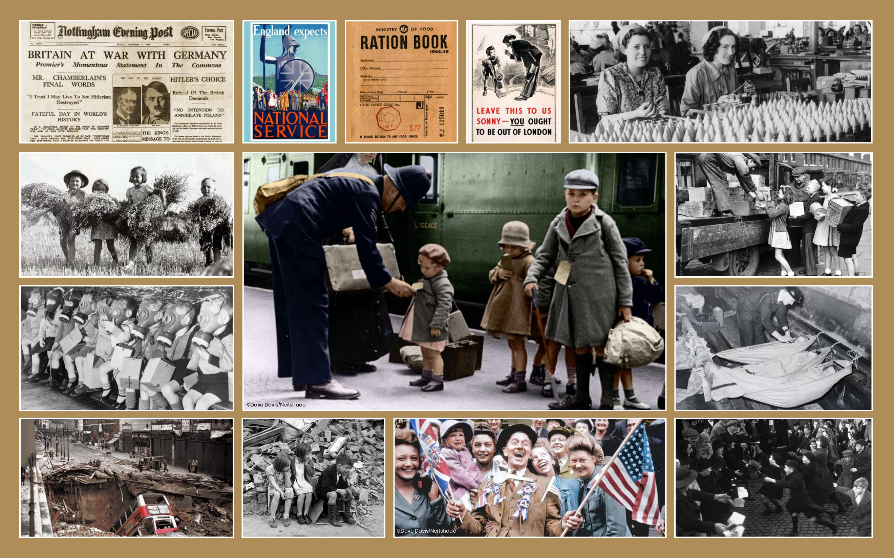  The Second World War
Unit Genre | Narrative | Oral text type | Storytelling
Vocabulary | Tier 1 examples: bomb, threat, air raid, shelters, gas mask, reunited,  horror, hammock  Tier 2 examples: ration, coupon, ammunition, evacuated/evacuees, irrevocably, sombre, munitions, camaraderie, rubble  Tier 3 examples: blitz
Lesson resources | The King’s Speech, multimedia links

Fortnightly plan
Lesson 1 | Digital poster (Story mode)  Digital poster (Explore mode): Talk and discussion  Readers’ theatre: The King’s speech | Lesson 3 | Digital poster (Explore mode): Talk and discussion  Storytelling: This is my story
Lesson 2 | Digital poster (Story mode): Recap  Vocabulary quiz  Digital poster (Question mode)  Pair talking task: Who am I? | Lesson 4 | Digital poster (Poem mode): ‘In Flanders Fields’  Digital poster (Let’s Talk! mode): Iconic images

Lesson 1
Digital poster (Story mode)
Play either the Story mode 1 (starters) or Story mode 2 (flyers) for the class, depending on the ability level.

Digital poster (Explore mode): Talk and discussion
Go to the Explore mode of the poster. Focus on the image of the newspaper report on the top row. Ask the students the following questions:
- What can we learn from this image? (Prime Minister announced/declared/made a statement that Britain was at war)
- What date was this declaration made?
- What word indicates that this was an important announcement? (momentous)

Choose ONE of the recordings below.
https://www.youtube.com/watch?v=zxew7HJS_Zo – from the movie The King’s Speech
https://www.youtube.com/watch?v=opkMyKGx7TQ – original recording of King George V1 speech

- Ask children to listen to watch/read the King’s speech (Resource 1)
- Ask them to consider why this was such a strong and powerful speech by the King. E.g.
  - strong and emotive language – grave hour, fateful, forced, conflict, challenge, fatal, time of trial, dark days, war, battlefield
  - powerful phrases – perhaps the most fateful in our history/it is unthinkable
  - use of repetition – over and over again
  - figurative language – as if I were able to cross your threshold and speak to you myself/might is right
  - awareness of other points of view – the task will be hard
  - strong conclusion – we shall prevail

Readers’ theatre: The King’s speech
Organise the children into pairs. With their partner, have them prepare to read the King’s speech aloud (Resource 1). Tell them to carefully consider the importance of the King’s message and decide how best to represent that message through tone of voice, pace, emphasis, use of pause, eye contact, etc.
Each child practises reading the piece aloud to their partner. Encourage each pair to present the speech to another pair.

Lesson 2
Digital poster (Story mode): Recap
Play either the Story mode 1 (starters) or Story mode 2 (flyers) for the children again. Make sure they understand all of the vocabulary.

Vocabulary quiz
- Ask children how many compound words/phrases with the word ‘air’ can they think of. (E.g. aeroplane, airport, aircraft, airsick, airbag, airspace, airstrip, airtight, airway, airfield, airline, airbrush; idioms: e.g. to walk on air; hot air; clear the air)

- Introduce the word blitz (German word for ‘lightning’. Nazi Germany aerial (taking place in the air) bombing campaign against Britain). Connect it to the term blitzkrieg (German word for war is ‘krieg’. Blitzkrieg means ‘lightning war’: an aerial warfare strategy used by Nazi Germany which was rapid, violent and instilled shock and fear into the British civilians).

- Explain that even though the word ‘blitz’ is a German word, it has been incorporated into the English language and has a few meanings. Ask children if they can think of a meaning for the word ‘blitz’ as we might use it today. (E.g. a sudden intense effort to do something – I did a cleaning blitz in the house; to process food in an electric mixer – blitz all the ingredients for 10 seconds)

Digital poster (Question mode)
Go to the Question mode of the poster. Listen to each question and discuss the answers with the children briefly.

Q1. | Who is pictured on the front of the newspaper? Why?
Q2. | What did Britain ‘expect’ of people in wartime?
Q3. | What information did people have to write on their ration book? Why?
Q4. | Why does the man in the poster say the boy should be out of London?
Q5. | Look at the boy wearing a cap in the main picture. How do you think he is feeling?
Q6. | How do you think the children in the fields and loading boxes feel about the work they are doing?
Q7. | Think of four words or phrases to describe the people waving flags.
Q8. | Would you enjoy spending a night underground in a hammock? Why or why not?
Q9. | How do you think life changed for men, women and children during the war?
Q10. | Imagine you are one of the people pictured. Describe how you were feeling when the photo was taken.

Pair talking task: Who am I?
Divide children into pairs:
Child A chooses any one of the people represented in the images on the poster.
Child B questions child A to try to identify which person they’ve chosen.
This can be a Yes/No game, where child A is only allowed to answer questions with a ‘yes’ or a ‘no’ OR Child A may be allowed to give complete answers to Child B’s questions. The children then switch roles. (E.g. Are you an adult/child? What are you wearing? Where are you standing/sitting? What are you doing? How are you feeling?)

Lesson 3
Digital poster (Explore mode): Talk and discussion
Go to the Explore mode with students again. Focus on the large image in the centre of the poster.
Ask students the following questions:
- What aspect of The Second World War is depicted in this image? (Evacuation)
- Can you explain what the term ‘evacuation’ means? (e.g. remove a person from a place considered to be dangerous to a safer place)
- Do you know any other forms of this word? (e.g. evacuate, evacuee – the person who is removed)
- Can you see another similar sounding piece of a word in the middle of this word? (vac – vacate – to leave empty)

Focus on the image of the children sleeping on hammocks in the London Underground. Ask children the following questions:
- Who can you see in this image?
- Where are the children? Why?
- What do you think it must have been like there?
- Why did people take shelter in the London Underground?
- Would you like to have to endure such hardship? Why not?
- Do you think it would have been frightening to be subject to bombing raids?
- Elicit/introduce and explain some of the following vocabulary as appropriate – blackout, siren, shelter, underground, strong, secure, fortified, dark, damp, bomb, incendiary, explosives
- Optional: Play this video clip from from the opening scene of The Chronicles of Narnia, The Lion, the Witch and the Wardrobe https://www.youtube.com/watch?v=NPs2IXlDxRk to get an idea of what an air raid might have been like:

Focus on the first two images on the bottom row of the poster. Ask children
- What might the impact of the blitz have been on people and property? (Explain that the blitz lasted eight months and that one-third of London was destroyed.)
- Elicit/introduce and explain some of the following vocabulary as appropriate - carnage, damage, destruction, devastation, razed to the ground; fear, dread, horror, dismay, alarm, confusion, panic, hysteria, frenzy

Storytelling: This is my story
Tell children to choose one of the people from the photographs on the poster and to pretend to be them.
Tell them to use the poster to help them create the story of their life during the war (e.g. how they heard the country was at war; the changes that happened in their daily life during the war; what they did; how they felt during an air raid; whether they were evacuated; what happened to their family; what their city looked like; how they heard the war was over, and how this made them feel)

Lesson 4
Digital poster (Poem mode): ‘In Flanders Fields’
Go to the Poem mode of the poster and play the poem ‘In Flanders Fields’ by John McCrae:

In Flanders Fields
By John McCrae

In Flanders fields the poppies blow
Between the crosses, row on row,
That mark our place; and in the sky
The larks, still bravely singing, fly
Scarce heard amid the guns below.
We are the Dead. Short days ago
We lived, felt dawn, saw sunset glow,
Loved and were loved, and now we lie

In Flanders fields.
Take up our quarrel with the foe:
To you from failing hands we throw
The torch; be yours to hold it high.
If ye break faith with us who die
We shall not sleep, though poppies grow
In Flanders fields.

Children listen to the poem as it is recited, preferably without looking at the text for the first one or two encounters.
Ask them to identify a favourite word/phrase/image from the poem and encourage them to explain why they have chosen this.
Replay the poem with the text and encourage the students to join in where they can. Repeat this a number of times. Draw students’ attention to the run-on lines in the poem as they read.

Ask students the following questions:
- Where is this poem set? Why?
- Who is speaking in the poem?
- What words tell us that they are not alive anymore? (crosses mark our place; now we lie)
- How do you think they died?
- What are they asking us to do?
- What phrase is used to tell us what they want us to do? (we throw the torch)
- What is the symbolism of the poppies in the poem?

Digital poster (Let’s Talk! mode): Iconic images
Go to the Let’s Talk mode of the poster and display each flashcard and talking point:

Flashcard 1: The Battle of Iwo Jima
This photo of US soldiers raising the flag after defeating the Japanese Army in the Battle of Iwo Jima, is one of the most iconic images of the Second World War. Why do you think this is the case?

Flashcard 2: Hitler salutes marching Nazis
What does this photo tell you about Hitler? Why do you think so many Germans followed him?"

Flashcard 3: Women in war
After the war, most women in employment had to return to the home. Some women weren't happy about this. Why do you think they felt that way?"

Flashcard 4: Post-war Germany
Many German cities like Dresden were completely destroyed by bombing. How do you think Germans felt after the war?"

Lesson Resource 1

The King’s Speech

In this grave hour, perhaps the most fateful in our history, I send to every household of my peoples, both at home and overseas, this message, spoken with the same depth of feeling for each one of you, as if I were able to cross your threshold and speak to you myself. For the second time in the lives of most of us, we are at war. Over and over again we have tried to find a peaceful way out of the differences between ourselves and those who are now our enemies. But it has been in vain. We have been forced into a conflict, for we are called to meet the challenge of a principle, which, if it were to prevail, would be fatal to any civilized order in the world. Such a principle, stripped of all disguise, is surely the mere primitive doctrine that might is right. For the sake of all that we ourselves hold dear, it is unthinkable that we should refuse to meet the challenge. It is to this high purpose that I now call my people at home, and my peoples across the seas, who will make our cause their own. I ask them to stand calm and firm and united in this time of trial. The task will be hard. There may be dark days ahead, and war can no longer be confined to the battlefield. But we can only do the right as we see the right, and reverently commit our cause to God. If one and all we keep resolutely faithful to it, then, with God's help, we shall prevail.

King George VI, 3 September 1939

