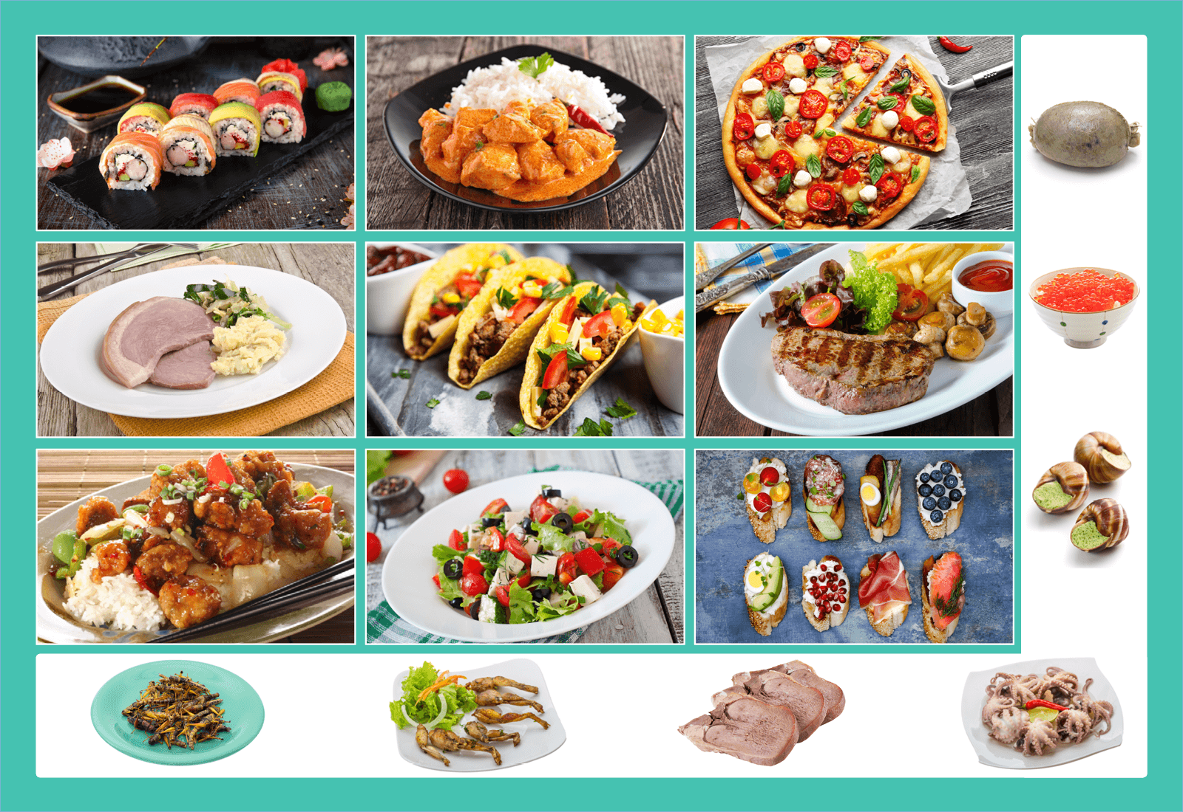
Class | 2nd Class | Theme | Food
Unit | 13 | Subtheme | All types of food
Unit genre | Poetry
Vocabulary | Tier 1 examples: raw, dishes, fillings, takeaway, expensive  Tier 2 examples: delectable, scrumptious, traditional,  contemporary, consumed, popularity, feature  Tier 3 examples: delicacy, cuisine
Lesson resources | Multimedia links
Element | Learning outcome | The child should be able to …
Communicating | LO 1 | Actively listen and attend to the story.
 | LO 2 | Use intonation correctly when chanting an instruction.
 | LO 3 | Use language to work collaboratively.
Understanding | LO 5, 6 | Develop vocabulary on the theme of food.  Use idioms, e.g. The punishment must fit the crime.  Develop greater metalinguistic awareness, e.g. Bon appetit.
Exploring and using | LO 11  LO 12 | Retell a familiar story. Engage and use language playfully.
 | LO 13 | Use language to justify and explain choices.

Fortnightly plan
Lesson 1 | Digital poster (Story mode)  Digital poster (Explore mode): Talk and discussion  Pair talking task: Odd-one-out  Word tennis: Food pairs | Lesson 3 | Digital poster (Explore mode): Talk and discussion  Digital poster (Activity mode): Activity questions  - Bon Appetit;  - Vile Vittels
Lesson 2 | Digital poster (Story mode): Recap  Digital poster (Question mode)  Storytime: Strega Nona  Group talking task: Tell it again! | Lesson 4 | Digital poster (Label mode)  Digital poster (Poem mode) – Greedy Dog

Lesson 1
Digital poster (Story mode) LO 1
Play either the Story mode 1 (starters) or Story mode 2 (flyers) for the class, depending on the ability level.

Digital poster (Explore mode): Talk and discussion LO 4, 5, 6, 7, 9, 10, 14
Go to the Explore mode of the poster. Ask children the following questions:
In the poster can you see …
- A food that is red, blue, green, white, pink, yellow, brown? Can you name any other food that has this colour? What colour is your favourite food? Would you eat a food that is grey/purple/black? Why?
- A food that is a vegetable, carbohydrate, dairy, meat, poultry, fish? What do we know from the food pyramid about food choices?
- A food that grows in the ground, on a tree, on a bush?
- A food that is used to garnish a meal? (Spring onion, basil, chives, herbs)
- A food that tastes spicy, bitter, sweet, sour, fresh, etc?
- A food that is chewy, crunchy, mushy, creamy, etc?
- A food that is baked, boiled, fried, etc?
- Alphabet food – food that begins with…
- Can you list the foods in alphabetical order? (e.g. avocado, bacon, basil, blueberry, cabbage, caviar, cheese, chicken, chilli, chips, chorizo, coriander, cranberry, cucumber, dip, eggs, feta cheese, fennel, frog legs, haggis, ham, ketchup, lettuce, locusts, mince, mozzarella, mushroom, octopus, ox tongue, olive, onion, pepper, pizza, potato, radish, sauce, spring onion, snail, sweet and sour)
- Containers for serving food? (Dish, plate, bowl, taco shell, platter)
- Cutlery? (Knife, fork)
- Equipment? (Pizza cutter)
During this whole-class discussion, revise vocabulary on the theme of food developed in Junior Infants (Unit 13) and Senior Infants (Units 13, 14)
Encourage individual children to take on the role of teacher and ask questions based on the poster. When the children are familiar with the vocabulary associated with the poster, organise them into pairs. Encourage them to continue asking and answering questions on the theme based on the poster..

Nouns: Red pepper, apple, tomato, strawberry, raspberry, red onion, watermelon, peas, kiwi, cucumber, cabbage, celery, avocado, banana, carrot, potato, kiwi, dough, pizza base, tomato sauce, cheese, toppings – mushrooms
Adjectives: Delicious, scrumptious, fresh, tasty, juicy, creamy, crunchy, horrible, disgusting, nasty, burnt, messy, raw, icy, cool, cold, chilled, freezing, delicious, tasty, scrumptious, creamy
Categorical terms: Appetisers, condiments, cutlery, equipment, utensils, delicacy
Synonyms: Delicious/yummy/tasty/scrumptious/mouth-watering,delectable; hungry/starving/ravenous/peckish; eat/gobble/scoff/nibble/tuck into
Verbs: Boil, bake, roast, fry, deep fry, serve, prepare, slice, chop, cut, garnish, roll, stew, poach, scramble, season, sprinkle, toss, spread, mix, marinate, stir, garnish, beat, serve, coat, decorate, fold, shake, grate, whip, pour

Pair talking task: Odd-one-out LO 5, 6, 10, 13
Based on the previous discussion support the childrent to make an odd-one-out game. Make a list of four items where one is different from the rest based on the categories above, e.g. a list of foods which have the same colour/are prepared in the same way/start with the same sound, etc.
When children are familiar with the rules of the game, encourage them in pairs to generate a set of odd-one-out lists to try out on their friends.

Word tennis: Food pairs LO 5, 6
Name one item from a pair of food items and ask the children to name the other item. When the children are familiar with the game, they play the game in pairs. Examples of food pairs:
- Curry and rice
- Steak and chips
- Lettuce and tomato
- Chips and ketchup
- Salt and pepper
- Strawberries and cream
- Bread and butter
- Jelly and ice-cream
- Fish and chips
- Tea and toast
- Milk and sugar
- Bacon and eggs

Lesson 2
Digital poster (Story mode): Recap LO 1
Play either the Story mode 1 (starters) or Story mode 2 (flyers) for the children again. Make sure they understand all of the vocabulary.

Digital poster (Question mode) LO 8, 9, 13, 14
Go to the Question mode of the poster. Listen to each question and discuss the answers with the children briefly.

Q1. | What kind of food is shown in the photo on the top left?
Q2. | Which country does curry come from?
Q3. | Which country does pizza come from?
Q4. | In which country is sushi a traditional dish?
Q5. | What kind of cheese is usually found on top of a pizza?
Q6. | Which of these dishes is a traditional food in Mexico?
Q7. | What kind of insects are considered a delicacy in some cultures?
Q8. | Which of these dishes would you most like to eat?
Q9. | Why do you think different foods are popular in different countries?
Q10. | Do you know any traditional Irish dishes?

Storytime: Strega Nona LO 1, 2, 7, 12
Listen to the story of Strega Nona by Tomie de Paola:
https://www.youtube.com/watch?v=ULUG8IIo9-8
Ask the children if they can hear any food/cooking words. (Pasta pot, bubbled, boiled, simmer, steaming, hot, forks, plates, platters, bowls, helpings, pouring …). Now ask the following questions about the story:
- What was the old lady’s name? (Strega Nona)
- What language is this? (Italian)
- What does this mean (Grandma Witch)
- Where did she live? (Calabria, Italy). Locate Italy on a map.
- Did you hear any other words in Italian in the story?(Grazia – thank you; Si – yes)
- Do we know how to say these words in any other language? (Gaeilge; Ask children with different L1 to share how to say the words in their languages.)
- What do you think Strega Nona wrote on the sign in the Town Square?
- What special instructions did she give Big Anthony about the pasta pot (Do not touch the pasta pot)
- Can you speak the instructions as Strega Nona – what tone of voice do you think she used/what pace did she speak at? Why?
- Sing along with the ‘Pasta Pot Song’ (Bubble, bubble pasta pot; boil me some pasta nice and hot; I’m hungry and its time to sup; boil enough pasta to fill me up; enough enough pasta pot; I have my pasta nice and hot; so simmer down my pot of clay; until I’m hungry another day)
- Why do you think that the townspeople wanted to string him up – referring to Big Anthony?
- What did Strega Nona mean when she said the punishment must fit the crime?
- What words can we think of to describe how Big Anthony felt when he had eaten all the pasta? (e.g. full, bursting, stuffed)

Another suitable story for this theme is Cloudy with a Chance of Meatballs (Judi Barrett).
https://www.youtube.com/watch?v=M5WTrmLIhgk

Group talking task: Tell it again! LO 3, 11
Organise children in groups. Ask each group to choose another story on the topic of Food that they know, e.g. Goldilocks and the Three Bears, The Gingerbread Man, Hansel and Gretel, Jack and the Beanstalk, the Princess and the Pea, The Little Red Hen …
Have groups prepare a retelling of the story, deciding who will tell which part.
Give each group an opportunity to present their retelling of the story.

Lesson 3
Digital poster (Explore mode): Talk and discussion LO 5, 6, 7
Go to the Explore mode with children again. Explain that Strega Nona lived in Italy and cooked traditional Italian food. Much of the food we eat today is associated with other countries and has a name which is not an English word. Ask the following questions:
- What food can you see on the poster that has a name which is not an English word? (Sushi, pizza, taco, feta. Explain that curry is an English word now but originally came from the Indian word kari, meaning sauce, referring to a dish cooked in a sauce with spices. Explain that escargot is the French word for snails and caviar comes from the French word caviar meaning fish eggs.
- Can you think of food we eat which comes from Italy and has an Italian name? (Pepperoni, salami, panini, pancetta, mascarpone, mozzarella, cappuccino, cornetto)
- Do you notice anything unusual about these Italian words? (They all end in a vowel.)
- What food can you see on the poster that has a name which ends in a vowel? (Sushi, pizza, pepperoni, taco, feta, avocado, parma ham,tapa(s), bruschetta, chilli, mozzarella, pepperoni)
- The word ‘rice’ ends in a vowel also. How is it different? (The vowel is not pronounced)
- Do you know any food we eat which comes from France and has a French name? (Baguette, crepe, quiche, croissant, éclair, madeleine …); What French words/phrases are associated with food? (e.g. gourmet; bon appetit)
- What are names of some Mexican/Spanish foods?(e.g. tortilla, taco, chorizo, paella); German foode?(e.g. hamburger, gummibear, pumpernickel bread, marzipan). Explain that Bagel is a Polish word; Wok is a Chinese word.
- If there are children of other nationalities in the class, encourage them to teach about their native foods. Compare and contrast the type of food/cooking in different countries.

Digital poster (Activity mode): Activity questions LO 2, 13
Go to the Activity mode of the poster. Listen to each question and discuss the possible answers with the children.

Q1. | I love rich, spicy foods – the hotter the better! What should I order?
Q2. | The weather is too hot to eat anything heavy. I'd like something light, healthy and nutritious. Any ideas?
Q3. | It's my first time in a Japanese restaurant - what should I order?
Q4. | I am on holidays in France and I want to try some traditional French cuisine. What do you suggest?
Q5. | I am going to the new Mexican restaurant this evening, but I don't know what to expect. What do you think will be on the menu?
Q6. | I like to be adventurous when it comes to food. I'd love to try something REALLY unusual that most of my friends aren't brave enough to eat! What will I order?

Vile vittels: Gussie’s Greasy Spoon LO 5, 6, 7, 12

Explain to children that we don’t always enjoy the taste/flavour/texture/colour/smell of food we are not familiar with.
Read the poem aloud to the class, asking them whether or not the food appeals.

Gussie’s Greasy Spoon

Every day, at ten past noon,
I enter GUSSIE’S GREASY SPOON,
I plop down in the nearest seat,
and order food unfit to eat.
I try the juice, it’s warm and vile,
the scrambled eggs are green as bile,
the beets are blue, the beans are grey,
the cauliflower tastes like clay

At GUSSIE’S GREASY SPOON, the stew
is part cement, part hay, part glue,
it’s mostly gristle, ropy tough,
a tiger couldn’t chew the stuff.
The rancid soup is foul and thin,
a bit like bitter medicine,
the melon smells, the salad sags,
the mashed potatoes seem like rags.

One whiff of Gussie’s weird cuisine
makes stomachs ache, turns faces green,
her mouldy muffins have no peers,
they’ll make you sick for forty years.
The coffee’s cold, the cake is stale,
the doughnuts taste like pickled whale,
yet, every day, at ten past noon,
I eat at GUSSIE’S GREASY SPOON.

Have a discussion based on the poem. Invite all children to discuss the answers to the questions in pairs, then some children share their thoughts with the class.
What food is available to eat at Gussie’s Greasy Spoon?
What colours are the food?
How does the food look/taste?
Which food do you think is worst?
What words are used to describe that food?
What would you choose to eat in Gussie’s Greasy Spoon?
Why is it called Gussie’s Greasy Spoon, do you think?

Group Talking Task LO 12, 13
Devise an advertisement for Gussie’s Greasy Spoon to entice people to dine there.

Lesson 4
Digital poster LO 6, 7
Go to the Label mode of the poster. Review the vocabulary. Have children take turns dragging the labels onto the correct location in the poster.

Digital poster (poem mode): Greedy Dog LO 12
Go to the Poem mode of the poster and play the poem, Greedy Dog by James Hurley:

Greedy Dog
By James Hurley

This dog will eat anything.
Apple cores and bacon fat,
Milk you poured out for the cat.
He likes the string that ties the roast
And relishes hot buttered toast.
Hide your chocolates! He's a thief,
He'll even eat your handkerchief.
And if you don't like sudden shocks,
Carefully conceal your socks.
Leave some soup without a lid,
And you'll wish you never did.
When you think he must be full,
You'll find him gobbling bits of wool,
Orange peel or paper bags,
Dusters and old cleaning rags.
This dog will eat anything,
Except for mushrooms and cucumber.
Now what is wrong with those, I wonder?

Ask children, what food words are used in the poem?
Can you replace each one with a synonym?
Why do you think the dog won’t eat mushrooms and cucumber?

Bushtucker Trial LO 13
Have the class watch a video of a bushtucker trial from I’m a Celebrity, Get Me Out of Here: https://www.youtube.com/watch?v=SWV9C9MaQRA
Ask children you were in charge of the programme, what bushtucker trial would you set and why?

