Class | 2nd Class | Theme | The world around us
Unit | 11 | Subtheme | Countries in Europe
Unite genre | Report
Vocabulary | 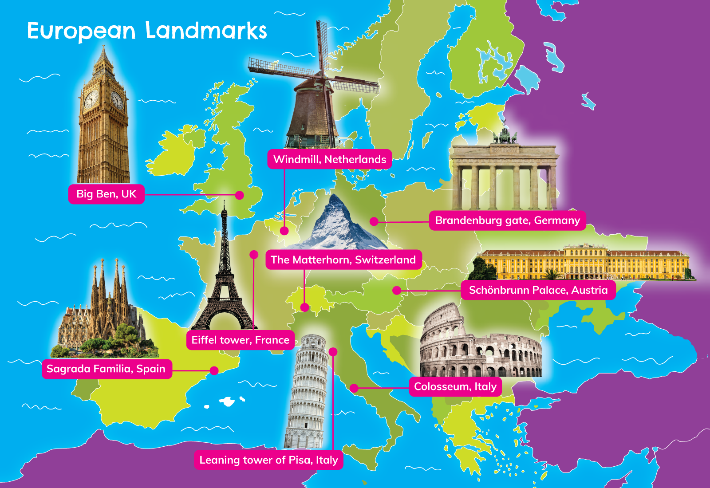  Tier 1 examples: palace, mountain, pyramid, tourist, windmills  Tier 2 examples: flock, chimes, spectacular, historical,  entertainment, amusement  Tier 3 examples: manmade, landmark, summit, gladiator
Lesson resources | Multimedia links
Element | Learning outcome | The child should be able to …
Communicating | LO 1 | Actively listen and attend with interest to video clips.
 | LO 2, 3 | Using appropriate language to present to an audience.  Use language to work collaboratively, e.g. Research and report.
Understanding | LO 4 | Connect two or more sentences when making a report, e.g. Research and report.
 | LO 5, 6 | Learn and use sophisticated vocabulary on the topic.
 | LO 7 | Demonstrate understanding by using language to justify .
Exploring and using | LO 9 | Use language to ask and answer increasingly complex questions.
 | LO 12 | Engage with and use language playfully.
 | LO 13 | Use language to report a trip to another country.

Fortnightly plan
Lesson 1 | Digital poster (Story mode)  Digital poster (Explore mode): Talk and discussion  Silly sentences!  Turn and tell  Can you remember? | Lesson 3 | Digital poster (Explore mode): Talk and discussion  Think and talk  Digital poster (Activity mode): Multiple choice questions  Spotlight on The Colosseum
Lesson 2 | Digital poster: Recap  Digital poster (Question mode)  Research and report | Lesson 4 | Digital poster (Label mode)  Digital poster (Poem mode): Globetrotting  Add some more!

Lesson 1
Digital poster (Story mode) LO 1
Play either the Story mode 1 (starters) or Story mode 2 (flyers) for the class, depending on the ability level.

Digital poster (Explore mode): Talk and discussion LO 4, 5, 6, 7, 9, 10, 13
Go to the Explore mode of the poster. Zoom in on Ireland. Ask the children to look carefully at the image they can see on the poster. Now invite them to play the silly sentences game. They must tell you why each sentence is silly.

Silly sentences!
- This is America. (Ireland)
- Ireland is a city. (Country)
- We live in the province of (name an incorrect province)
- There is one county in Ireland.
- Our county is called … (give an incorrect name here)
- Our county colours are … (give incorrect information here)
- The nearest city/town/village to us is … (give an incorrect name here)
- The largest (capital) city in Ireland is Kilkenny. (Dublin)
- People born in Ireland are called Americans. (Irish)

Ask the children to say the sentences again but this time correctly. If there are children from other countries, encourage them to introduce themselves in a similar manner, making reference to their country of birth.

Zoom out and spotlight the United Kingdom. Play Big Ben’s chimes for the class. https://www.youtube.com/watch?v=wqslA_CKub8
Explain that Big Ben is a landmark. A landmark is something (e.g. a structure, building, feature, object) that is especially associated with a particular place. Ask the children:
- Is there a particular landmark which is associated with the place where you live?
- What do you know about it?

Zoom out to show the full poster. Point out the borders which designate each of the countries on the map. Explain that all these countries together make up the continent of Europe. Ask the following questions:
- How many of the countries can we name? (Use the ‘Countries of the World – Europe’ song to teach the countries of Europe. https://www.youtube.com/watch?v=zOti8U_-BNM)
- Who has visited any of these countries?
- Would you say that these European countries are islands? Why not? We say that some of these countries are landlocked (surrounded by land with no borders with the sea). Which countries are landlocked?
- What do we call the people who live in Europe (Europeans; inhabitants of Europe)
- What do we call the people who live in each of these countries? (British/English/Scottish/Welsh; French; Spanish; German; Italian, etc.)

Turn and tell LO 3, 13
Encourage children who have travelled to a European country/somewhere in Ireland to report about their visit to a partner. Scaffold the children to give information about forms of travel, names of countries/regions, towns visited, climate, activities, infrastructure, comparing and contrasting with Ireland if appropriate.

Can you remember? LO 5, 6, 7, 9
Organise the children in pairs. Play the following video clip, which gives information about the Eiffel Tower: https://www.youtube.com/watch?v=-LYh7Npojn0 (Begin at 1.28).
Ask children to work with their partner to make a list of questions about the Eiffel Tower (e.g. what is it made of; how high is it; what is the bottom part called; where is it; how is it lit up at night; who designed it; where did it get its name; how many sections has it; how often is it repainted; what colour is it …)
Turn to another pair and ask them the questions. See how much they can remember! Who had the most questions? Who was able to answer the most questions correctly?

Lesson 2
Digital poster (Story mode): Recap LO 1
Play either the Story mode 1 (starters) or Story mode 2 (flyers) for the children again. Make sure they understand all of the vocabulary.

Digital poster (Question mode) LO 8, 9, 13, 14
Go to the Question mode of the poster. Listen to each question and discuss the answers with the children briefly.

Q1. | Where is Big Ben located?
Q2. | Where is the Eiffel Tower located?
Q3. | Which of these landmarks is not manmade?
Q4. | Which of these monuments is still under construction?
Q5. | How many people visit the Eiffel Tower each year?
Q6. | How old is the Colosseum in Rome?
Q7. | Why does the Leaning Tower of Pisa lean?
Q8. | Why do you think tourists like to visit famous landmarks?
Q9. | Which of these landmarks would you most like to visit? Why?
Q10. | The Matterhorn is a natural landmark. Can you think of any other famous natural landmarks?

Spotlight the image of the Matterhorn. Ask the class to think about the answers to the following questions:
- What is this? (Mountain)
- What is it called? (Matterhorn)
- Where is it located? (Border between Switzerland and Italy)
- Why is it a natural landmark? (Not constructed by humans)
- Why is this particular mountain a landmark? (Beauty; climbing challenge)

Research and report LO 2, 3, 4, 7, 13
Set up jigsaw groups in the classroom with five children in each group, numbered 1-5. New groups are formed from each number – all the number 1s go together, 2s. etc. Give an information sheet with two interesting facts about the Matterhorn to each group. Nominate two children in each group to read the interesting facts. Children then return to their base groups and present the two pieces of interesting information they learned.
Some groups may present all the facts they have learned about the Matterhorn to the class/another class.

Examples of interesting facts:
- Group 1: The Matterhorn is located in the Swiss Alps and is one of the highest mountains in Europe; The Matterhorn is a triangular-shaped mountain, like a pyramid.
- Group 2: Approximately 3,000 people climb the Matterhorn each year; More than 500 people have died climbing the Matterhorn.
- Group 3: The first woman to reach the summit of the Matterhorn was Lucy Walker in 1871; the oldest person to climb the Matterhorn was 90 years of age.
- Group 4: The name Matterhorn comes from Matte – meadow + horn – peak = a peak in the meadow; Walt Disney and his family enjoyed visiting the village at the foot of the Matterhorn and he built a bobsled ride called the Matterhorn in Disneyland California.
- Group 5: The Toblerone chocolate bar was invented by Theodor Tobler who lived in Switzerland; the shape of the bar was inspired by the pyramid shape of the Matterhorn.

Lesson 3
Digital poster (Explore mode): Talk and discussion LO 5, 6, 13
Go to the Explore mode with the children again. Focus on:
- Differences between countries in Europe (e.g. size, location, language)
- What connects all the countries? (Belong to the continent of Europe; European inhabitants)
Display the European Union Flag (see lesson resource 1, or link here: https://upload.wikimedia.org/wikipedia/commons/thumb/b/b7/Flag_of_Europe.svg/810px-Flag_of_Europe.svg.png. Explain to the children that 28 countries in Europe are members of the European Union.

Think and talk LO 3, 5, 6, 7
Organise the children in pairs. Ask them to look carefully at the flag. Ask: ‘What do you think this flag tells us about the European Union?’ Ask children to think about and explain what they think the following mean:
- The colours used
- The stars
- The shape

Listen to the anthem of the European Union.
https://www.youtube.com/watch?v=oiW1G8HYcdc
Explain to the class that the anthem is actually from a piece of music composed by the famous composer Ludwig van Beethoven, who was born in Germany. Spotlight Germany on the map.

Digital poster (Activity mode): Multiple choice questions LO 2, 13
Go to the Activity mode of the poster. Listen to each multiple choice question and discuss the possible answers with the children. Select the correct answer to move on to the next question.

Q1.  A1. | Where is the Leaning Tower of Pisa?  England / Switzerland / Italy / France
Q2.  A2. | How many people visit the Sagrada Familia in Barcelona each year?  10,000 / 100,000 / 1 million / 3 million
Q3.  A3. | What kind of landmark is the Matterhorn?  A church / A mountain / A tower / A pyramid
Q4.  A4. | What were the armed fighters who fought in the Colosseum called?  Soldiers / Warriors / Gladiators / Fighters

Spotlight on the Colosseum LO 5, 6, 9, 13
Spotlight the Colosseum and ask the children the following questions:
- Do you think this is an old or a new landmark? Why?
- The Colosseum is an amphitheatre. Can you hear a word you know in that word? (Theatre).
- What happens in a theatre? Have you ever been to a theatre? Turn and tell your partner about it.
- An amphitheatre is an open-air theatre. Does the Colosseum look like the theatres in Ireland today? How is it different?
- What do you think this building may have been used for? (Entertainment)

Lesson 4
Digital poster (Label mode) LO 6, 7
Go to the Label mode of the poster. Review the vocabulary. Have children take turns dragging the labels onto the correct location in the poster.

Digital poster (Poem mode): Globetrotting LO 12
Go to the Poem mode of the poster and play the poem Globetrotting by Kerri Ward:

Globetrotting
Kerri Ward

I’d like to see the world someday
I’ll travel the globe, so I can say:
I went to Rome to meet the Pope
In Switzerland I hit the slopes
In the North Pole I rode a Polar Bear
In Spain I wove seashells through my hair
In Cork I kissed the Blarney Stone
In Italy I had an ice-cream cone
In China, Chinese was all I spoke
In Paris I spent so much I went broke
In Cornwall I visited Cornish coves
In India I walked the mango groves
In Russia I saw a famous dome …
And after that I flew back home.

Speak the poem with appropriate expression and actions.

Add some more! LO 12
Ask the children if they can add some more. They choose any one of the countries on the map and add two lines about that country to the poem.

Make a Map
Ask children to make a map of the area where they live with some of the most important landmarks included.

Lesson resource 1
