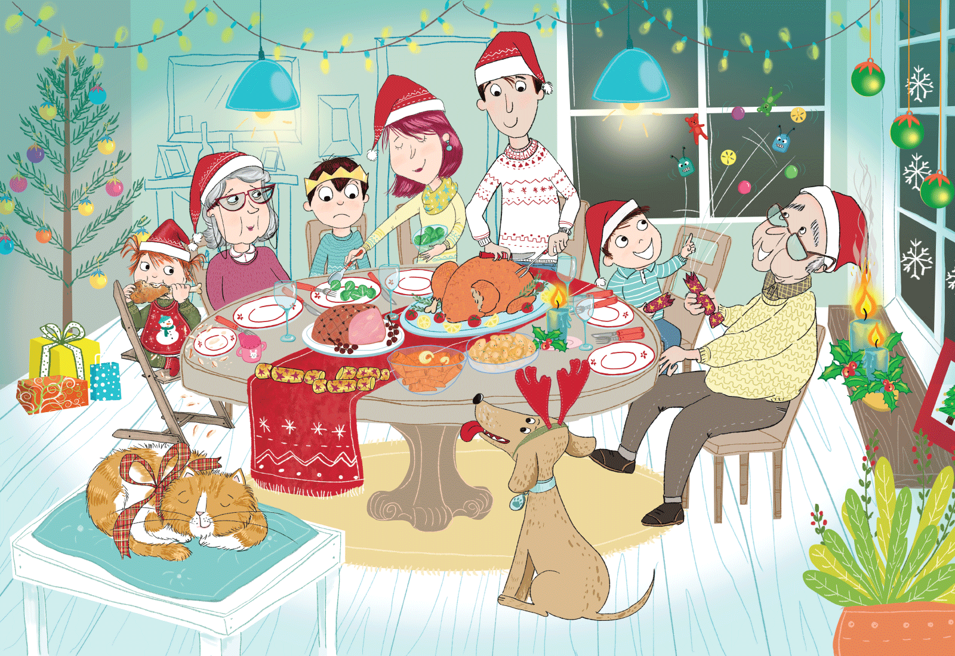
Class | 2nd | Theme | Shopping
Unit | 7 | Subtheme | Christmas presents
Vocabulary | Tier 1 examples: ham, presents, turkey, lights, candles,  snowflake, Brussels sprouts, antlers, baubles, tree,  Christmas crackers, Santa hat  Tier 2 examples: oblivious, mishap, opportunity
Lesson resources | Christmas tree template, black and white printable copy of the poster
Element | Learning Outcome | The child should be able to …
Communicating | LO 1 | Listen to new information
 | LO 2, LO 3 | Initiate and take turns in conversations on the theme of Christmas.  Work in pairs/groups using gestures, expressions, signs and language style where appropriate.
Understanding | LO 4 | Use tenses correctly in more complex sentences.  Use less common adjectives, qualifiers and connectives to elaborate on descriptions.
 | LO 5, LO 6 | Acquire and understand new vocabulary and phrases from an oral text about Christmas.  Understand, and use, nouns, adjectives, verbs and adverbs to describe a Christmas dinner (e.g. turkey; carving; gobbles; Brussels sprouts).  Understand and use different words or phrases that mean the same thing.
 | LO 7 | Ask and respond to a range of questions about Christmas.  Respond to a series of instructions in order to identify correct pictures or words. Justify responses through role play. Ask and follow simple directions.
Exploring and using | LO 8, LO 9 | Use open and closed questions and elaborate on answers so as to develop understanding and extend thinking.
 | LO 10 | Name and categorize different words associated with Christmas.
 | L0 11 | Orally recount an event using appropriate tense and oral vocabulary.
 | LO 12 | Listen and respond to the poem Christmas Morning. Explore the creative aspects of language.
 | LO 13 | Explain and justify information.
 | LO 14 | Describe and reflect on events outlined in the poster.

Fortnightly plan
Lesson 1 | Digital poster (Story mode)  Digital poster (Explore mode) – talk and discussion  Pair talking task: Darragh’s dilemma | Lesson 3 | Digital poster (Explore mode) – talk and discussion  Digital poster (Activity mode) – multiple-choice questions  Group task: What are they saying?  Decorate the tree
Lesson 2 | Digital poster – recap  Digital poster (Question mode)  Oral recount | Lesson 4 | Digital poster (Label mode)  Digital poster (Poem mode)  What is it?

Lesson 1
Digital poster
Play either the Story mode 1 (starters) or Story mode 2 (flyers) for the class, depending on the children’s ability level.

Digital poster: Talk and discussion
Go to the Explore mode of the poster. Ask the children the following questions:

- How many different foods can you see on the table? What kind of foods are they? What foods do you like/dislike? Why?
- How many people are happy in the story? Why do you think they are happy? Is there anyone who is not happy? Why is this?
- Who is sitting next to Grandma?/Who is sitting across from Grandad?/Who is sitting beside Dad?/Who is standing next to Mum?
- Tiddles the cat is oblivious to what is going on. What does this mean? Can you use oblivious in a sentence?
- What did Darragh and Grandad win in their cracker? Do you pull crackers at Christmas? What have you won?
- Can you think of a word you could use instead of gobbles/pounce/tucking into, etc?

Nouns Use the spotlight tool to focus on different items as they are named. Use the pen tool to categorise the various items after they have been named, e.g. food (turkey; ham; Brussels sprouts) decorations (baubles; lights; crackers; presents), clothing (bib; hat)
Describe the various items using increasingly complex syntax. (Size; colour; shape; texture; position; action)
Verbs, e.g. relaxing; gathering; carving; dishing; pouncing; tucking; pulling; burning; waiting; sitting; gobbling; noticing
Adverbs, e.g. quickly; softly;
Adjectives, e.g. cosy; pretty; twinkling; green; festive; delicious; coloured; bright; twinkling
Prepositions, e.g. next to; across; around

Pair talking tasks: Darragh’s dilemma
Present the children with the following dilemma:

There are three presents, still wrapped, under the tree. Darragh does not want to eat his dinner – he wants to open the presents under the tree first! He thinks the present he wanted the most is still under the tree.
How does Mum convince Darragh to eat his dinner first? How might Darragh respond? Role play the conversation that might happen between Mum and Darragh.

Children can then share their role play with the whole class or with another pair.

Lesson 2
Digital poster: Recap
Play either the Story mode 1 (starters) or Story mode 2 (flyers) for the children again. Make sure they understand all of the vocabulary.

Digital poster
Go to the Question mode of the poster. Listen to each question and discuss the answers with the children briefly.

Q1. | Where are the family?
Q2. | What is Dad doing?
Q3. | Where is the cat?
Q4. | Do you think Duffer the dog is hungry? Why?
Q5. | Does Darragh like Brussels sprouts? How do you know?
Q6. | Where do you think Darragh got his crown?
Q7. | What is your favourite thing to eat on Christmas Day? Why?
Q8. | What do you think Tiddles the cat is dreaming about?
Q9. | What do you think Grandad will do when he realises his hat is on fire?
Q10. | What would you do if you saw something catching fire?

Oral recount: The day Grandad’s hat caught fire LO 7, 11
Organise the children into pairs or groups and ask them to devise an oral recount of what happened after Grandad’s hat caught fire. Ensure that the children include who, what, when, where, and how during their recount.

Safety first!
Organise the children into groups and ask them to describe the rules for fire safety that are in place in their home. Have each group design a poster to communicate the rules. Share the posters with the whole class.

Lesson 3
Digital poster: Talk and discussion LO 5, 6
Go to the Explore mode with the children again. This time, focus on vocabulary development.

Describe an object in the poster, e.g. start with ‘The Turkey’. Add one descriptive word – ‘The Large Turkey’. Then add another – ‘The Large Delicious Turkey’. Then add another ‘The Large Delicious Golden Turkey’. Then ask the children to select an object from the poster, e.g. the tree. Invite the children one at a time to add descriptive words to describe the tree, (e.g. bright; tall; green; colourful) Brussels sprouts (e.g. green; round; squishy; smelly) etc.

Digital poster: Multiple-choice questions LO 2, 7, 13
Go to the Activity mode of the poster. Play each multiple-choice question for the children and see if they can correctly categorise the items that are associated with Christmas. Encourage them to provide explanations and justifications for their responses.

Q1.  A1. | Which of these are you most likely to be doing on Christmas morning?  Boy eating Easter eggs / Boy sleeping / Boy opening presents /  Girl getting face painted
Q2.  A2. | Which of these would you be most likely to eat for Christmas dinner?  Turkey / pizza / salad / spaghetti
Q3.  A3. | Which one of these would you be most likely to have for dessert on Christmas day?  An ice cream cone / plum pudding / chocolate / barm brack
Q4.  A4. | Which of these activities are you most likely to do after Christmas dinner?  An easter egg hunt / Watching a movie / Trick or treating / Going to a parade

Group task: What are they saying? LO 2, 4, 7, 12
Give the children a copy of the poster (see Lesson Resource 1). Ask them to draw speech or thought bubbles above each character’s head. What is Mum/Dad/Darragh thinking/saying? Ask the children to share and justify their ideas with the whole class.

Decorate the tree LO 7
Organise the children into pairs. Give each pair an outline drawing of a Christmas tree (see Lesson Resource 2).

Child A gives instructions to Child B to draw objects on the outline of the Christmas tree, e.g. draw a large yellow star on top of the tree. On the bottom branch, draw three baubles – a yellow one, a green one and a blue one. Under the tree, draw three presents – two small and one large – and put the small presents to the right of the large present. Put a red stocking on the top branch, on the left. Put two candy canes on the branch below the star. Child B should then give instructions to child A to do the same thing, based on what they have already drawn. Each pair should then compare their results.

Lesson 4
Digital poster LO 5, 6, 7
Go to the Label mode of the poster. Review the vocabulary. Have the children take turns dragging the labels onto the correct location in the poster.

Digital poster: Christmas Secrets LO 12
Go to the Poem mode of the poster and play the poem:

Christmas Secrets
By Aileen Fisher

Secrets long and secrets wide,
Brightly wrapped and tightly tied,
Secrets fat and secrets thin,
Boxed and sealed and hidden in,
Some that rattle, some that squeak,
Some that caution ‘Do Not Peek’…
Hurry, Christmas, get here first,
Get here fast… before we burst!

Organise the children into pairs or groups. Ask them to locate the rhyming pairs in the poem. Then ask the children what other rhyming words they can think of, e.g. wide and tied – side, hide, ride, etc. Ask the children to share the rhyming words they found with another pair/group, then with the rest of the class

What is it? Feely bag activity LO 5, 6, 10, 13 Take an opaque bag, and then place some Christmas items (e.g. bauble; tinsel; star; a bow; a candle; candy cane; holly; etc.) in the bag. Ask one child to come to the top of the class, place his/her hand in the bag and feel one of the objects.

Tell the children to ask questions to ascertain what the object is. Encourage the use of descriptive language that includes texture and size, e.g. It’s smooth and round and large; it’s long and silky; it’s hard and pointy, etc.

