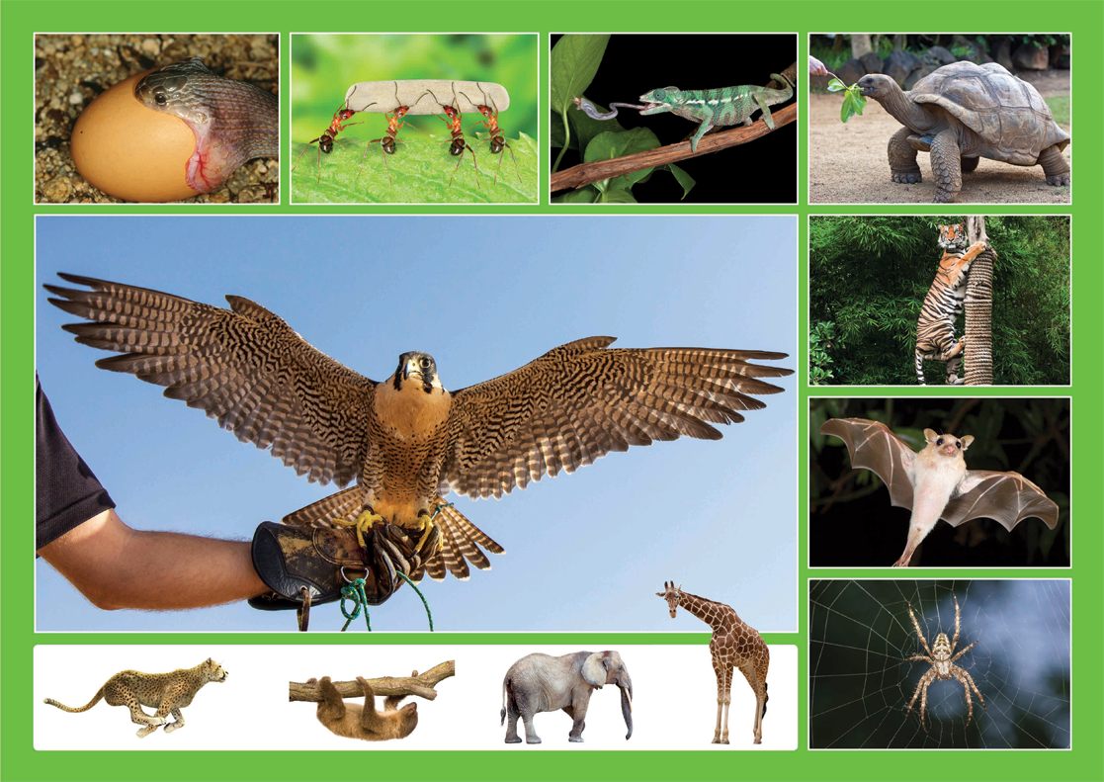
Class | 1st Class | Theme | Animals
Unit | 4 | Subtheme | Amazing animals
Vocabulary | Tier 1 examples: cheetah, giraffe, tortoise, etc.  Tier 2 examples: unique, ability, species  Tier 3 examples: echolocation, predator, prey
Element | Learning Outcome | Learning Objective (The child will be enabled to…)
Communication | LO1 | Listen to new information
 | LO2, LO3 | Initiate and take turns in conversations on the theme of Amazing Animals.  Work in pairs/groups, using gestures, expressions and signs where appropriate.
Understanding | LO4 | Use tenses correctly in more complex sentences.  Use less common adjectives, qualifiers and connectives.
 | LO5, LO6 | Acquire and understand new vocabulary and phrases from a factual oral text about animals.  Understand and use nouns, adjectives, verbs and adverbs to describe animals (e.g. tiger, striped, roar, quickly).  Understand and use specific language for spatial and location contexts (e.g. up in the tree, on a branch, in the sea, etc.)
 | LO7 | Ask and respond to a range of questions about animals.  Respond to a series of instructions in order to draw an animal.
 | LO8, LO9 | Use open and closed questions and elaborate on answers.
 | LO10 | Name and categorise different animals.
Exploring and using | LO12 | Listen and respond to the poem ‘Eletelephony’ and explore the creative aspects of language.
 | LO13 | Deliver an oral report on an amazing animal.  Give instructions on how to draw an animal.  Justify their response to a question.
 | LO14 | Describe and explain actions and events.  Give reasons for a predicted outcome.

Fortnightly plan
Lesson 1 | Digital poster (Story mode)  Digital poster (Explore mode) – talk and discussion  Pair talking task – Guess the animal | Lesson 3 | Digital poster (Activity mode) – Who am I?  Digital poster (Explore mode) – talk and discussion  Oral report
Lesson 2 | Digital poster – recap  Digital poster (Question mode)  Absurdity activities  Pair/Group work – Draw the animal | Lesson 4 | Digital poster (Label mode)  Digital poster (Poem mode) – Eletelephony  Rhyming words

Lesson 1
Digital poster LO 1
Play either Story mode 1 (starters) or Story mode 2 (flyers) for the class depending on the ability level.

Digital poster: Talk and discussion LO 4, 5, 6, 7, 10, 14
Go to the Explore mode of the poster. Ask students the following questions:
- Look at the tortoise in the poster. Describe him? (Encourage the use of colour, size, texture, doing, position words in their description.) Pick another animal and ask for a description.
- I’m going to describe an animal. Can you name it? (For example, this animal is very large and moves slowly. He has big floppy ears and a long trunk. He is grey.)
- Can you name the fastest/slowest, tallest/smallest animals?
- Can you see a stripy animal; a small animal; a large animal; a slow animal; a fast animal; a slimy animal, etc. in the poster?
- The tiger is up in the tree. Why do you think he is there? What might have happened before/happen after this picture?
- The cheetah is running. Where do you think he is running to? Why?

Get the children to describe an animal. (Encourage the use of colour, size, texture, doing, position words in their description.)
Ask the children to sort and classify animals in different ways (for example, wings/no wings, can climb trees/cannot climb trees)

Pair talking task: Guess the animal LO 2, 3
First, model the activity for the children. Tell them you are thinking of an animal. Have them ask questions to ascertain information on what the animal is. Questions might include what the animal does, what sounds it makes, what size it is, where it lives, etc. When children think they know, they should ask, ‘Is it a XXXX?’ After they understand the game, they break into small groups or pairs and complete the same activity.

Lesson 2
Digital poster: Recap
Play either the Story mode 1 (starters) or Story mode 2 (flyers) for the children. Make sure they understand all of the vocabulary.

Digital poster LO 8, 9, 13, 14
Go to the Question mode of the poster. Listen to each question and discuss the answers with the children briefly.

Q1. | What is the snake eating?
Q2. | What is the tortoise eating?
Q3. | Where is the tiger?
Q4. | Why is the peregrine falcon amazing?
Q5. | How long does a giant tortoise live?
Q6. | What is the tallest animal in the world?
Q7. | How are snakes able to swallow such large things?
Q8. | What do you think a giant tortoise does to protect itself from a predator?
Q9. | Do you think it’s a good idea to climb a tree to escape from a tiger?
Q10. | If you could be any one of the animals on this poster for one day, which one would you be? Why?

Absurdity activities LO1, 8, 9
Present strange situations or oddities about animals that do not exist in the real world. The children’s task is to recognise the impossible or silly situation and comment on what’s wrong with the scenario.
- The Bat
The bat dived into the water and caught the fish.
(What’s silly about this sentence? Do bats live in caves or in the ocean? What seabird, whose name starts with pen_____, likes to catch and eat fish?)
- The Fierce Tortoise
The fierce tortoise chased the lion up a tree.
(What’s silly about this sentence? Is a lion frightened by sheep? Name two animals that climb trees.)
- The Polar Bear
The polar bear ate grass under the hot African sun.
(What’s silly about this sentence? Where do polar bears normally live? What large animal, whose name starts with el_________, would eat grass in Africa?)
- The Cow
The cow climbed the tree and swung from branch to branch.
(What’s silly about this sentence? Why can’t a cow climb a tree? Name an animal that has long arms and a tail, and is great at climbing trees?)

Pair/group work: Draw the animal LO2, 3, 7, 13
Print off simple pictures of animals or objects associated with animals.
Ask the children to form teams or pairs. One child is the instructor. The aim of the game is for the instructor to call out directions to the team on how to draw their chosen animal/object. For example, A Cat. ‘Draw a large circle. Draw a small circle on top of the large circle. Draw two small triangles for ears on top of the small circle. Draw two round eyes in the small circle. Draw a triangle nose in the small circle. Give the cat three whiskers. Draw a round mouth. Put a tail coming out of the bottom of the big circle.’

Lesson 3
Digital poster: Who am I? LO 8 and 9
Go to the Activity mode of the poster. Click on one of the numbered buttons to hear a statement about one of the animals. The children must guess the animal.

Digital poster: Talk and discussion LO 5, 6, 13
Go the Explore mode with the children again. Pick an animal and get the children to suggest adjectives describing that animal, verbs to identify what it does, and where it is found. Write these on the board. For example:

Animal | Adjective | Verb | Places
Tortoise | big  slow  gentle  old | plod  eats leaves  sleeps | jungle  water  in its shell

The children then combine the different elements to make different sentences. For example:
The big old tortoise likes to sleep in his shell every day.
The gentle, slow tortoise, plods along in the jungle.

Oral report LO 2, 3, 13
Divide the children into pairs or groups. Have them take turns to deliver an oral report on their favourite animal. Encourage the use of appropriate adjectives and verbs as per the previous activity.
Lesson 4
Digital poster LO 6
Go to the Label mode of the poster. Review the vocabulary. Have students take turns dragging the labels onto the correct position in the poster.

Digital poster: Eletelephony LO 12
Go to the Poem mode of the poster and play the poem.

Eletelephony
Once there was an elephant,
Who tried to use the telephant—
No! No! I mean an elephone,
Who tried to use the telephone—
(Dear me! I am not certain quite
That even now I’ve got it right.)
Howe’er it was, he got his trunk,
Entangled in the telephunk;
The more he tried to get it free,
The louder buzzed the telephee—
(I fear I’d better drop the song,
Of elephop and telephong!)

By Laura Elizabeth Richards

Rhyming words LO 2, 3, 12
Display the text of the poem. Have a volunteer read the poem aloud. Encourage the other children to listen carefully for the rhyming words. Have volunteers underline or highlight the rhyming words in the first two lines, the second two lines, etc. Have the children read all the underlined words aloud, noting that for each sensible word, there is a rhyming non-sense word in the pair. Explain this is a nonsense poem.

Divide the children into pairs. Ask them to orally make up their own nonsense poem on any animal and then perform for the class. Each poem should be no more than 4–5 lines.

